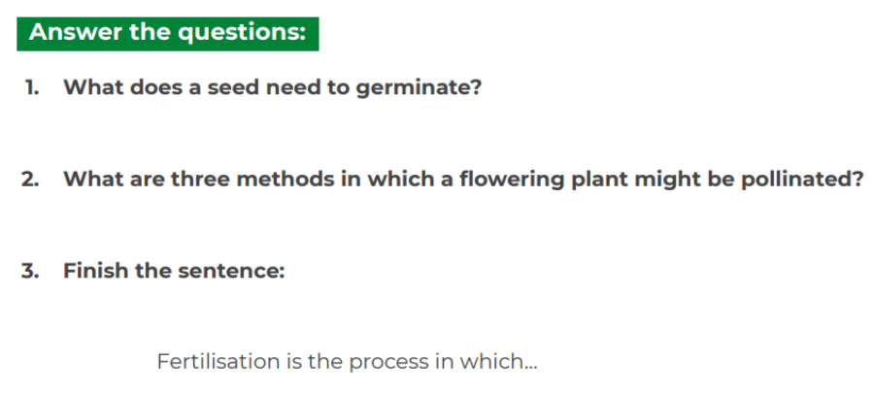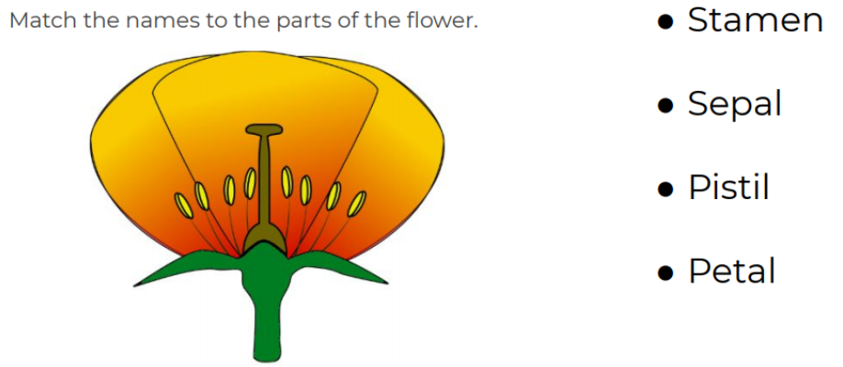

**Your challenge:**

After watching the video, can you present this information and explain the life cycle of a plant?

You can present this information in whichever format you choose. Just like Stephen Hawkings, you are now a Science expert in the life cycle of flowering plants.

Ideas of how you could choose to present his information:

-Could you make a video (like Miss Woolard and Mr Elliott) explaining the process?

-Could you create a 3D model with labels showing the process?

-Could you use your computing skills to create a PowerPoint?

-Could you create a poster with the lifecycle of a flowering plant on? (See attached sheet for an example layout)

We are sure you’ve got even more creative ideas than these.

Enjoy getting creative,

Miss Woolard and Mr Elliott

