Mummification – The Truth

Why did the Egyptians preserve bodies?
The Egyptians believed that when they died their soul left their bodies. After they were buried their soul would return and together with the body would live forever in the afterlife when the world had ended. Unless their body was preserved, it would be no good in the afterlife. Not everyone could afford to, it was a very expensive process that took around 70 days to complete.
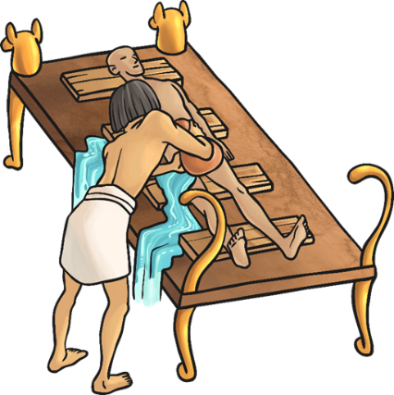
What was the process?
The body was taken to a place called the Beautiful House. It wasn’t as beautiful as the name suggests! The body was cleansed with palm wine and rinsed with water from the River Nile. Sometimes they would use a slatted bed on a slant. This would let fluids drain off and out of the body, and allow them to wrap the strips of linen around the body.
Organs
A cut was made on the left side of the body and the organs removed to stop the body decomposing. The liver, lungs, intestines and stomach were washed, dried in natron (which is a natural salt) and either wrapped in cloth to place in the body later or stored in canopic jars. The heart, responsible for intelligence and emotion, was left in the body as it was needed in the afterlife.
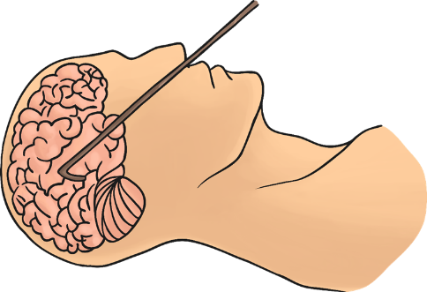
Brain
The brain wasn’t thought to be important! A long hook was pushed up through the nose to smash the brain to pieces, then either pull it out or lift the body so the liquefied brain would drain out through the nose. This prevented them having to damage the head or the skull.
Wrapping
The head and neck would be wrapped first, then the fingers and toes wrapped individually. The arms and legs were wrapped separately.
Did you know?
75% of the body is water. Wet things rot very quickly so the body was dried inside and out with natron. Natron absorbed the moisture but it could take 40-50 days.

