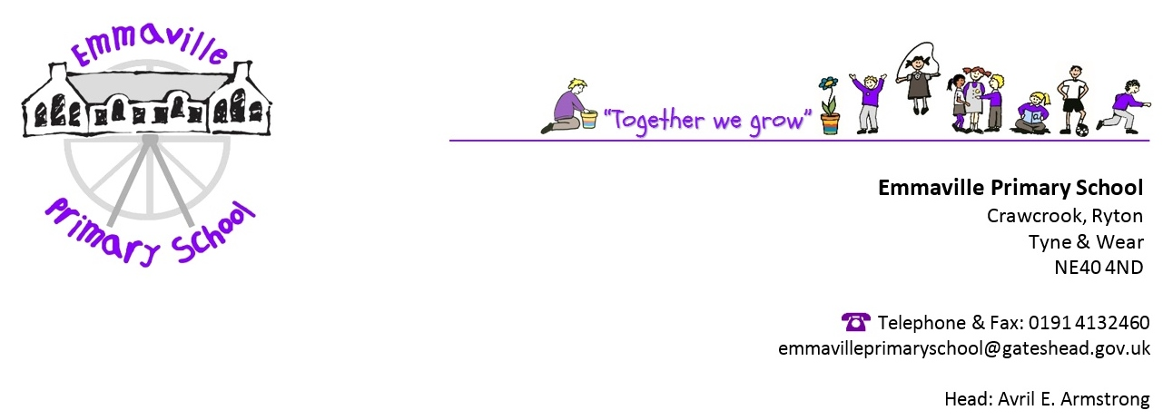

Monday 28th September 2020
Dear CBBC,
I am writing about your Horrible Histories ‘Splat the Rat’ sketch which shows what life was like on the Western Front.
I agree with some of the content about trench conditions, for example
_______________________________________________________________________________________________________________________________________________________________________________________________________________
But on the other hand
____________________________________________________________________________________________________________________________________________________________________________________________________________
I feel therefore that your programme could be improved, for example you could have included
______________________________________________________________________________________________________________________________________________________________________________________________________________________________________________________________________
Overall, I think that
_________________________________________________________________________________________________________________________________________________________
Yours sincerely

