2/12/20

LO: To count pounds

1. How much money is there?

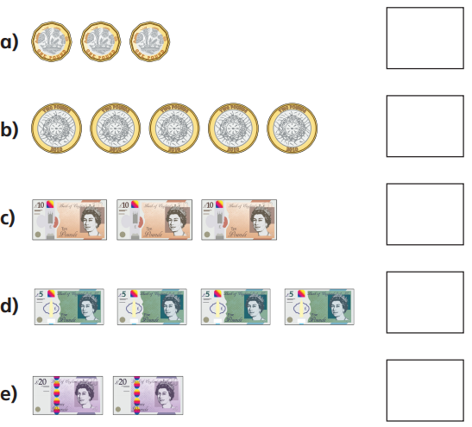

1. How much money is there?

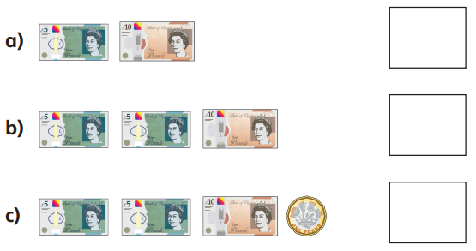`

1. Complete the bar models.

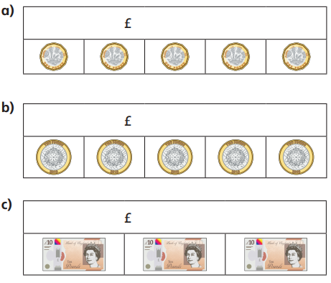

1. Thomas has this money.

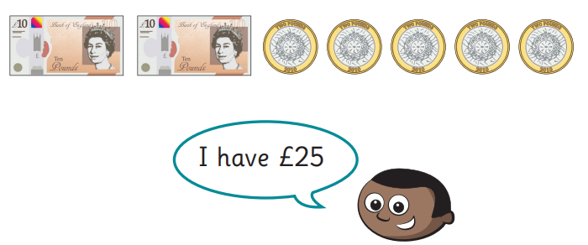

Is he correct?