LO:To learn to write Instructions

Monday
Northern and Southern Europe classes have received a letter. We thought you’d like to see it so we’ve attached a copy here:
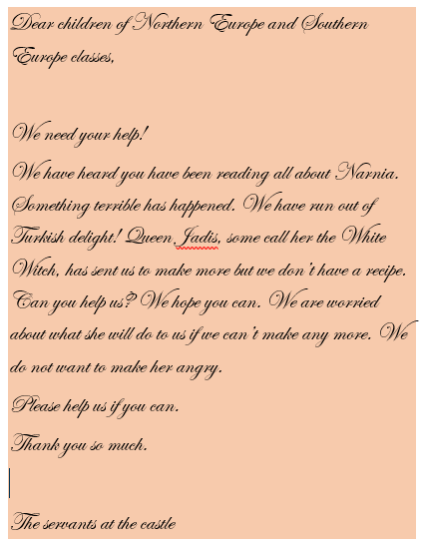
These must be the servants from the book we are reading in class. 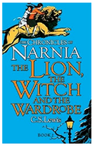
Poor servants! What do you think we could do to help them?
Maybe we could help them by writing a Turkish Delight recipe for them? What do you think?

Watch this video (STOP at 3.59 minutes) https://www.youtube.com/watch?v=Hso74H3O8Do

Have you ever tried Turkish Delight? Do you think you’d like it?

How To Make Turkish Delight
The sticky, soft, chewy sweet is usually incredibly floral with the flavours of rose water or orange blossom... but this version takes a green twist with Pandan extract and elderflower. Whether you know of it from Narnia or street markets and stalls across Europe and North Africa... when dusted in icing sugar and cornflour everybody want a square!
Ingredients
- 850 ml cold water
- 800 g caster sugar
- 1/4 lemon (juiced)
- 160 g cornflour
- 1 tsp cream of tartar
- 2 tbsp elderflower cordial
- 1 drop pandan extract
- 1 handful pistachio nuts
- 120 g icing sugar
- 30 g cornflour

Method
- First, dissolve the caster sugar into 350ml of the water and the juice from the quarter of a lemon in a deep saucepan over the stove. Carefully heat until the mixture reaches 118°C then take off of the heat.
- Next, dissolve the cornflour and cream of tartar in the leftover 500ml of cold water in a separate saucepan then heat to a boil as you whisk. As the mixture thickens, keep stirring slowly.
- Then, pour the sugar syrup into the cornflour paste slowly but surely, mixing well as you do it. It might go lumpy, but keep whisking. Heat very gently (as low as it’ll go) for an hour by which time you’ll have a thick, slightly golden syrup.
- After that, stir in the cordial and pandan, then mix in the pistachio nuts. Transfer to a lined and deep roasting tin (20cm x 20cm) and allow to cool and set for several hours.
- Finally, toss the icing sugar and cornflour together in a bowl. Cut the set Turkish delight into pieces and dust in a combination of the icing sugar and cornflour then serve or store in an airtight container.

Now read the Turkish Delight Recipe above. Start to draw your own text map for the Turkish Delight recipe. In class we will be doing this over 2 days. As you draw it, practice saying the text out loud. You can use the text map below to help you draw your own if you like.

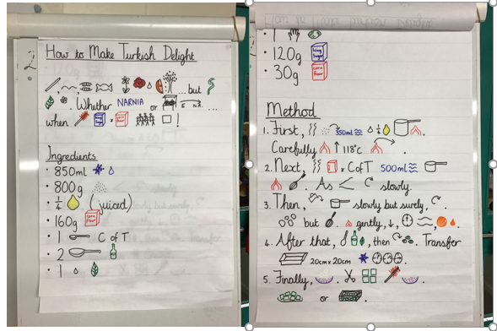
Tuesday – Continue drawing your text map and learning to say the text out loud.
Short Burst Writing Activity
Here is a Turkish Delight Poem:
Turkish delight
Fragrance of the east
Rose water, orange flower, lime
Dense, sticky jelly cubes
Pale hues
Heavily dusted with sugar snow
Sweet, soft pillows of flavour
Turkish delight
Now you are going to write your own poem about something you like to eat, perhaps chocolate cake or ice cream. Think about using all your senses to describe it. How it looks, feels, tastes, smells. Remember poems do not have to rhyme. Use some interesting vocabulary to describe it. Here are some words that might help you, but you can probably think of some of your own too.

sticky soft rich fluffy creamy dark
oozing dripping dribbling

If you have a dictionary or thesaurus at home, you could use this to help you.

Wednesday – understanding the text (Read as a reader)

Is there anything that you don’t understand in the text or that doesn’t make sense? Discuss this with a grown up. Are there any words that you are not sure of the meaning of? Use a dictionary or online dictionary to complete the chart below.

word | definition
pandan

Choose 4 of the words and write a sentence using that word to show that you have understood the meaning.

Thursday – Features of an instruction text
Look at a copy of the instruction text for How To Make Turkish Delight. Without looking at the list below, can you spot any features of an instruction text e.g. Title.
How many did you find? Can you say WHY this feature is needed?

Did you get all of these features? Did you find any more?
Title, introduction explaining what the item is and some detail about it, Ingredients sub heading, Quantities and ingredients (using precise measurement vocabulary), Method sub heading, Numbered steps for the method – in order, Conclusion.
You might also have noticed the imperative (or ‘bossy’) verbs. This tells the person who is reading the instructions what to do. Remember, verbs are action words.
Fill in the right hand side of the chart below with imperative verbs. Some have been done for you. How many imperative verbs can you find in the text? Perhaps you could underline them to help you.
You might also think of some other imperative verbs you could use e.g. get, chop, stir, put,

Adverbs | Imperative verbs
carefully | pour
rapidly | heat
Now we are going to use some adverbs to say HOW that thing should be done. You can put these in the left hand side of the table above. Two have been done for you.
Here are some you could use, but you might think of your own:
carefully, gently, slowly, firmly, evenly, sensibly, vigorously, continuously

Think carefully when choosing the adverb to make sure it goes with the verb.

