Summer 2 Week 7: Timetable Ideas
Celebration Week
 | 9.00 – 9.30 | 9.30 – 10.30 | 10.30-11.00 | 11.00 – 12.00 | 12.00 – 1.00 | 1.00 – 2.00 | 2.00 – 3.00
Monday - Friday | Exercise  See the options below under ‘exercise’ | Phonics  Go on a tricky word hunt. Hide red word cards around the house for your child to find. Can they find them and read the word?  Play Phonics Bloom Match Cards game  https://www.phonicsbloom.com/uk/game/match-cards?phase=2  Revise Set 1 and Set 2 sounds  Read Oxford Owl RWI and Epic texts  Watch one of the ‘red words’ and one of the ‘read and hold a sentence’ videos  https://www.youtube.com/channel/UCo7fbLgY2oA_cFCIg9GdxtQ | Break & Snack time | Maths  See further guidance under ‘maths’ below | Lunch | Celebration Week  See further guidance under ‘Celebration Week’ below | Daily walk / play in the garden / free play  Sing some teddy bear songs  Teddy Bear  The bear went over the mountain  Goldilocks Song

Exercise
- Teddy Time Exercise Programme https://www.youtube.com/watch?v=Uk_kVy1iLxk
- Just Dance Gummy Bear Dance https://www.youtube.com/watch?v=mYLhX6aJ32o
- Cosmic Yoga Bear Hunt https://www.youtube.com/watch?v=KAT5NiWHFIU

Maths
This week we will be using the Numberblocks to help us with our maths work
- Monday – looking at the number 19 https://www.bbc.co.uk/iplayer/episode/m000663t/numberblocks-series-4-nineteen Can you find 19 items from around your house (for example, 19 spoons, 19 socks or 19 buttons)? Notice that the number 19 is made up of 10 and 9. Play a game of number recognition Bingo.
- Tuesday – looking at the number 20 https://www.bbc.co.uk/iplayer/episode/m0006rr5/numberblocks-series-4-twenty Can you find 20 items from around your house (for example, 20 spoons, 20 socks or 20 buttons)? Notice that the number 20 is made up of two 10s and no 1s. Complete teddy bear counting to 20 sheet.
- Wednesday – Complete Teddy Bear colour by number sheet
- Thursday – Watch Numberblocks ‘I can count to 20’ https://www.bbc.co.uk/iplayer/episode/m0006s5q/numberblocks-series-4-i-can-count-to-twenty Play teddy counting game https://www.topmarks.co.uk/learning-to-count/teddy-numbers
- Friday – Can you find five or six teddy bears in your house to measure? Estimate which one is the tallest and which is the shortest. Write your estimations down. Can you measure your teddy bears using non-standard measures (cubes, crayons, satsumas)? Which teddy is the tallest/shortest? Were your predictions correct?
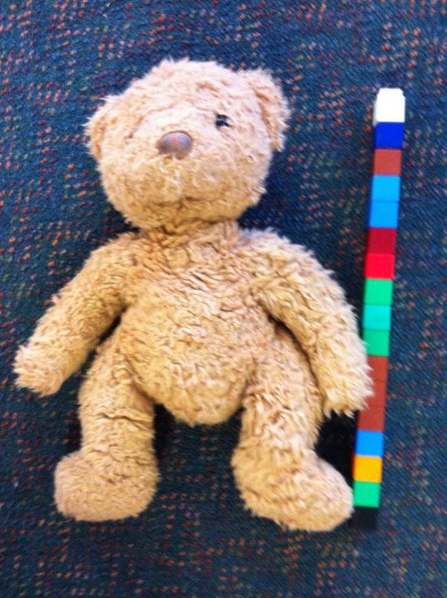

Celebration Week

- Monday:
Listen to the teddy bears picnic song https://www.youtube.com/watch?v=IrvkHAxnjzI Explain that, as it’s the last week of the school year, we are going to plan a teddy bears picnic for Friday. Decide which teddy bear you would like to bring and make an invitation for them using the template.
- Tuesday:
Have a range of foods from your kitchen in a basket or box. Sort the foods into categories (healthy and not healthy). Think about the foods you might like to take on your picnic. Write the foods you will need for your picnic on the teddy bear outline.
- Wednesday:
Read some teddy bear books. See below for some links to a range of stories you may like to listen to.
- Thursday:
- Make a party hat for you and your teddy bear for your picnic tomorrow. See below for some ideas.
- Friday:
Prepare your food and enjoy your teddy bears picnic! We would love to see some photographs of your celebration on Tapestry.

Party Hat ideas
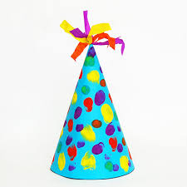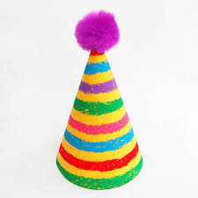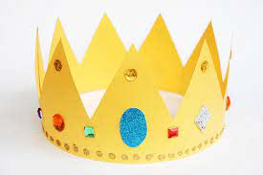
Bear Stories
- Not My Hats https://www.bbc.co.uk/iplayer/episode/m0003gvz/cbeebies-bedtime-stories-700-annette-badland-not-my-hats
- Leaf https://www.bbc.co.uk/iplayer/episode/m000fl1h/cbeebies-bedtime-stories-741-joanna-page-leaf
- Goldilocks and the three bears https://www.youtube.com/watch?v=0oUP2PFeOi8
- We’re going on a bear hunt https://www.youtube.com/watch?v=0gyI6ykDwds

