Friday 11th February 2022
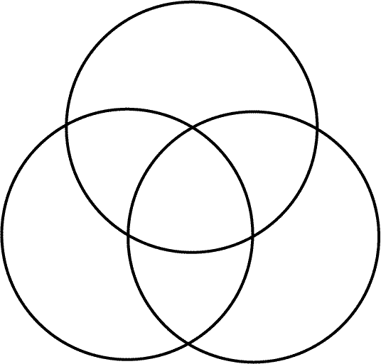
LO: To know what makes me feel happy, comfortable and healthy.

