Art – I can follow instructions to complete a drawing of Tutankhamun’s death mask.

When planning this activity, I thought about the Egyptian topic in History. I came across a brilliant series of art lessons on YouTube called ‘drawstuffeasily’.

With this in mind, I would like you to watch the following clip:

https://www.youtube.com/watch?v=Ecg96d_MkMg
It lasts y and a half minutes. I would watch it all the way through once and then watch it again, following the instructions and pausing the video clip when required.

If you follow the instructions your drawing should look something like this:

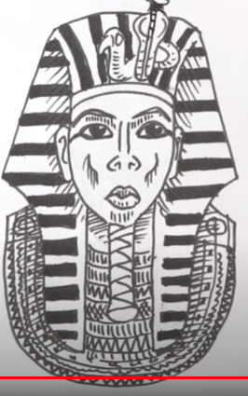

Enjoy and have fun. I can’t wait to see your finished drawings. Please post them on Seesaw so I can have a look. Thank you.

