Nursery Home Learning ideas
Week Beginning Monday 22nd March

Literacy
The Kindness Bucket:
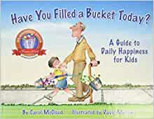

https://www.youtube.com/watch?v=3EuemNAo6XE
- Make a kindness Bucket – how can you fill yours today?

Watch Sesame Street Elmo’s World: Kindness
https://www.youtube.com/watch?v=BNNcpAcF0GM
What did Elmo do that was kind?
Hugs, helping his friend, helping to tidy.
Did being kind make Elmo happy or sad?
What can you do today that is kind?

Exercise Time!
https://www.youtube.com/watch?v=e7QFyr1Kxf8
‘Sticky Kids – if your happy’

https://www.youtube.com/watch?v=J7y9T-535XM
‘Action songs, wiggle and shake – stand up, sit down’

https://www.youtube.com/watch?v=npp1z32idrc
‘Chicken dance – Maximo’

Understanding The World
Read Jaspers Beanstalk
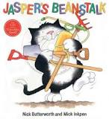

Phonics

https://www.youtube.com/watch?v=0T7Yp4K675A

Can you plant some seeds or bulbs and watch what happens?
What do you need to do to make them grow?

This week, we have some letter games to try:

Letter washing line:
Peg some letters that your child knows or nearly knows onto a real or small version of a washing line. Say a sound. Can they hit the sound with a ball / balloon / water pistol?

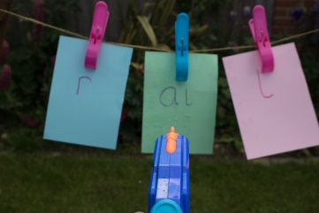

Maths
Use the link below:
Letter car park
Again, use letters that your child knows or nearly knows, to build confidence. Draw a car park with a letter in each parking space. Say a sound. Can they park their car in the correct bay?
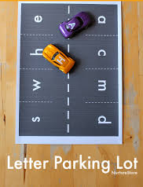

Name Treasure Hunt
Write down the letters of your child’s name, one letter on each piece of paper. Hide each piece of paper either around the house or in the garden. Can your child find them and put the letters back together again to make their name?

