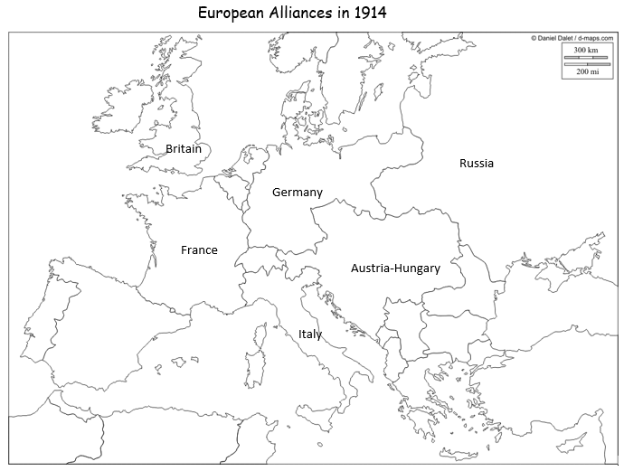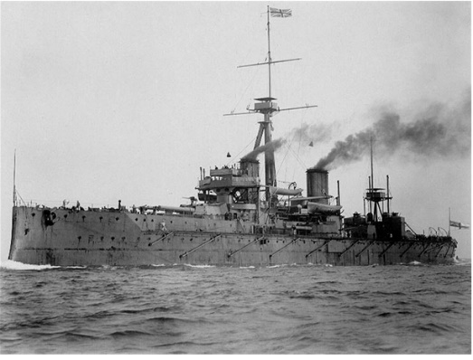

HMS Dreadnought

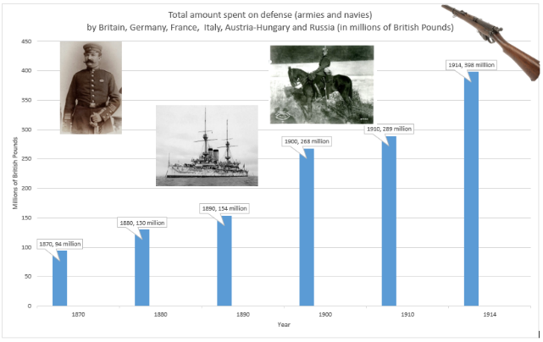

Total defence spending since 1870



HMS Dreadnought



Total defence spending since 1870



HMS Dreadnought



Total defence spending since 1870