WC 15/3/21
LO: Identify countries of the UK
Belfast
There are four countries in the UK. They are: 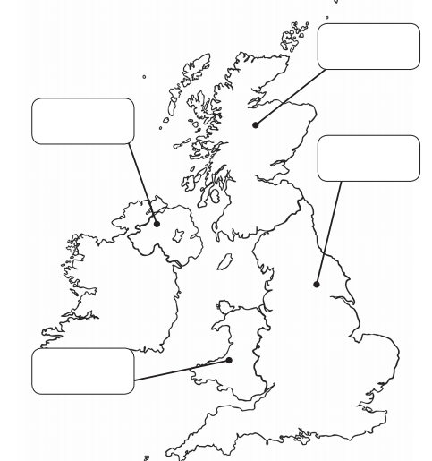
England
Scotland
Wales
Northern Ireland
Belfast is the capital city of _____________________________.

A fact about Belfast…

