Wednesday 24th March
LO: To write a letter of advice; to use a range of conjunctions

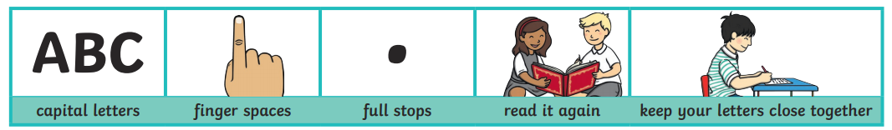

Wednesday 24th March
LO: To write a letter of advice; to use a range of conjunctions

Wednesday 24th March
LO: To write a letter of advice; to use a range of conjunctions

