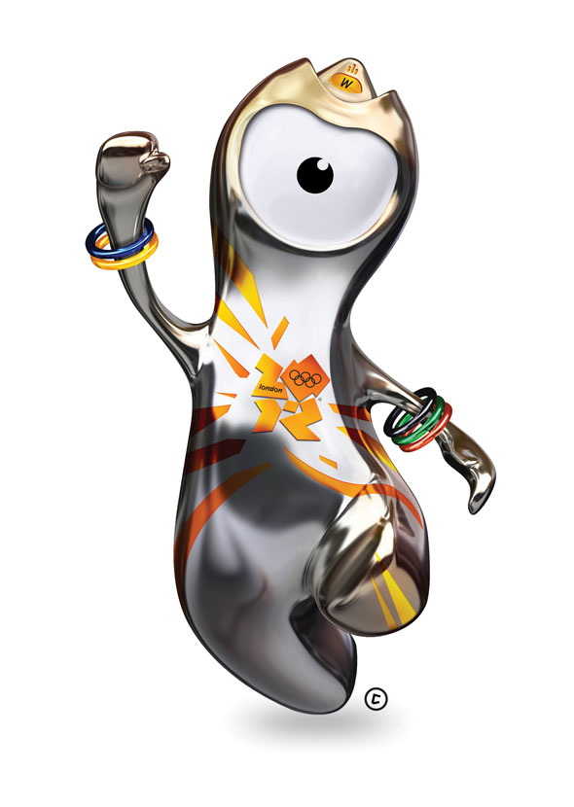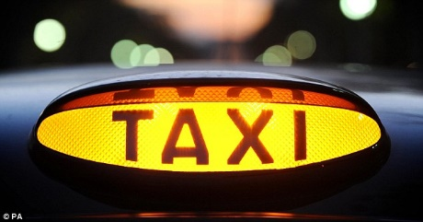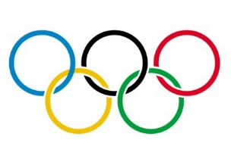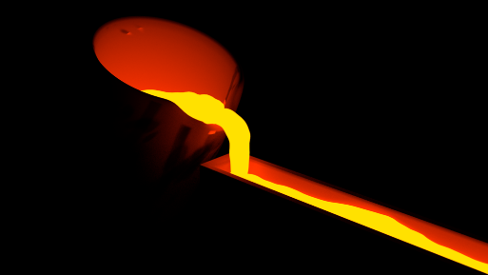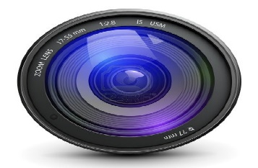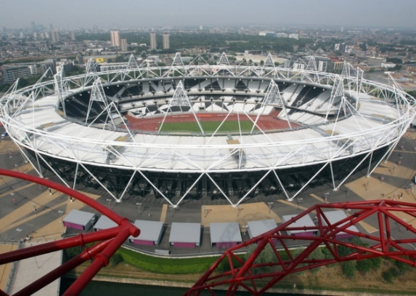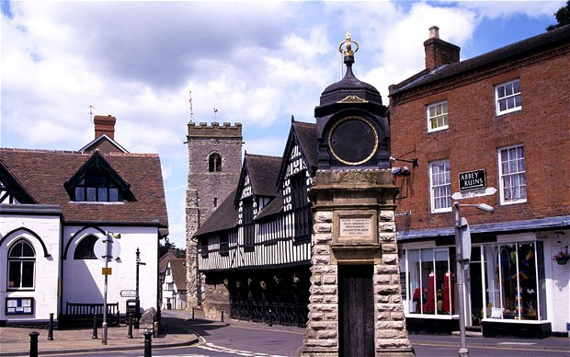**What is London 2012’s Olympic mascot all about?**

**Wenlock**

**Metallic look is explained as Wenlock being made from last drop of steel used to build Olympic stadium in London.**

**Five bracelets in the colours of the Olympic rings.**

**Eye is the lens of a camera, filming everything he sees.**

**Shape of forehead is identical to Olympic stadium roof.**

* **Named after the town of Munch Wenlock in Shropshire.**
* **Hosts traditional Munch Wenlock Games.**
* **Pierre De Coubertin’s source of inspiration for modern Olympics.**

**London black cab light**