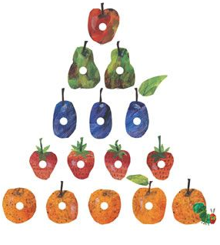
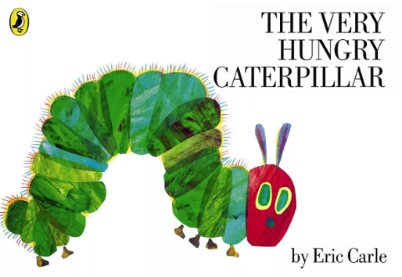
Nursery Home Learning ideas
Week Beginning Monday 18th January
The Very Hungry Caterpillar

Literacy
- Read the book, if you have it at home…or watch it:
https://www.youtube.com/watch?v=75NQK-Sm1YY
https://www.youtube.com/watch?v=btFCtMhF3iI
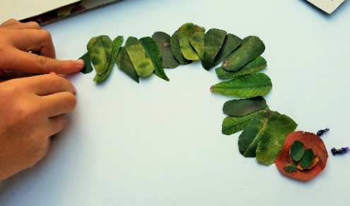
Cut & Stick Projects
- Make a caterpillar using leaves

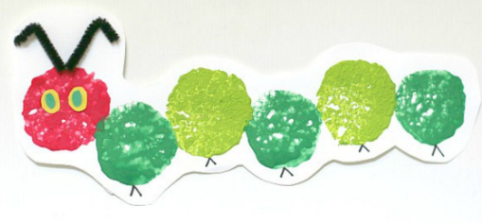
- Printing using an apple or a sponge

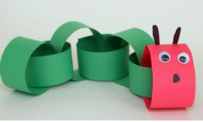
- Paper chain caterpillar

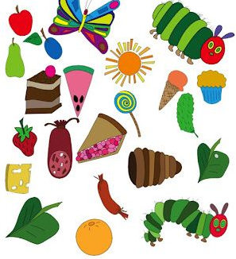
Cooking/baking
- Use some of the food that the caterpillar eats to create
Show us your creations on Tapestry.

Phonics
- All children could have a go at the rhyme game ‘hickory dickory dock:
https://www.phonicsplay.co.uk/resources/phase/1/hickory-dickory-dock

- If your child is due to start Reception in September, you may want to show them some of these phonics videos, using the links below. The videos are made by ‘Read, Write, Inc’, which is the phonics scheme that we use.

We normally begin to introduce the first sounds to children in nursery in the summer term, after Easter…but if your child is interested in letters now, then there is no harm in starting early. If your child shows no interest in the videos, please don’t panic…try again in a few weeks or we will try again in the summer term:
i = https://schools.ruthmiskin.com/training/view/qkvKtWbX/5UiAFNKE
n = https://schools.ruthmiskin.com/training/view/Djvzqiey/hCuZ5E5C
p = https://schools.ruthmiskin.com/training/view/eENYQ2CR/LV29wy59
g = https://schools.ruthmiskin.com/training/view/4qEpcEpS/e2RgEeQv
o = https://schools.ruthmiskin.com/training/view/VPS9tZPF/92wioIJl
Exercise Time!
- Cosmic Kids Yoga- The Very Hungry Caterpillar
https://www.youtube.com/watch?v=xhWDiQRrC1Y

- Kids Bop dancing
We love dancing to the Kids Bop Shuffle in Nursery. Give it a go at home.
https://www.youtube.com/watch?v=sHd2s_saYsQ

Maths
Use the link below:
https://whiterosemaths.com/homelearning/early-years/week-2/
Watch one video each day – from week 2 – sessions 1 to 5
Then have a go at the activity with your child

Fine Motor Challenges
Can you have a go at all 3 challenges this week:
- Make a pasta necklace.
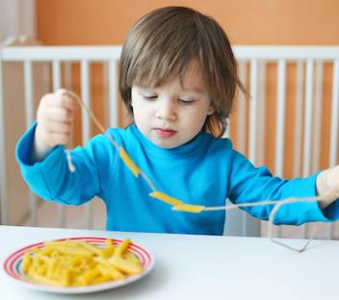
- Make crazy hair with pegs or pipe cleaners.
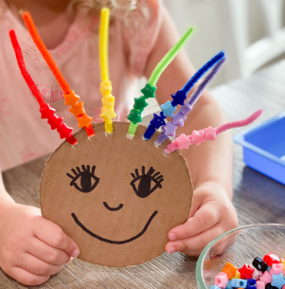
- Use scissors to make snips in a toilet roll tube and decorate.
