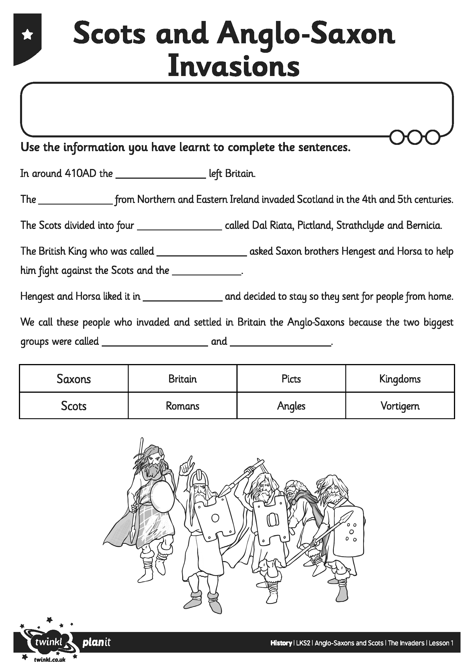
I can describe why, where and when the Scots and Anglo Saxons invaded Britain and explain what the seven Anglo Saxon kingdoms were.
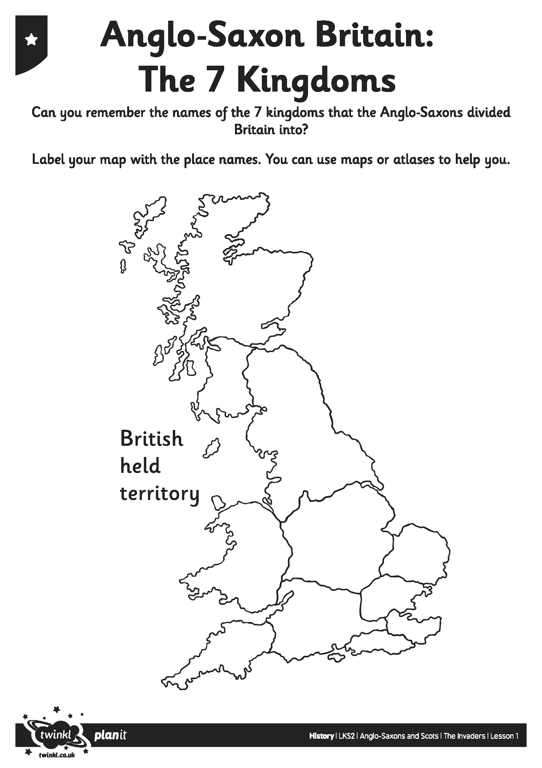
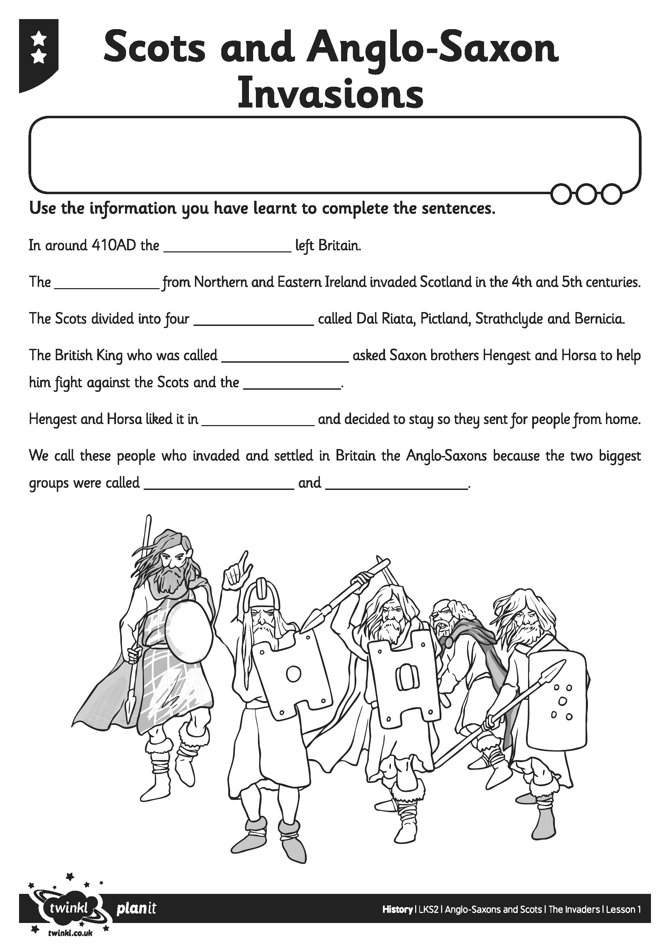
I can describe why, where and when the Scots and Anglo Saxons invaded Britain and explain what the seven Anglo Saxon kingdoms were.

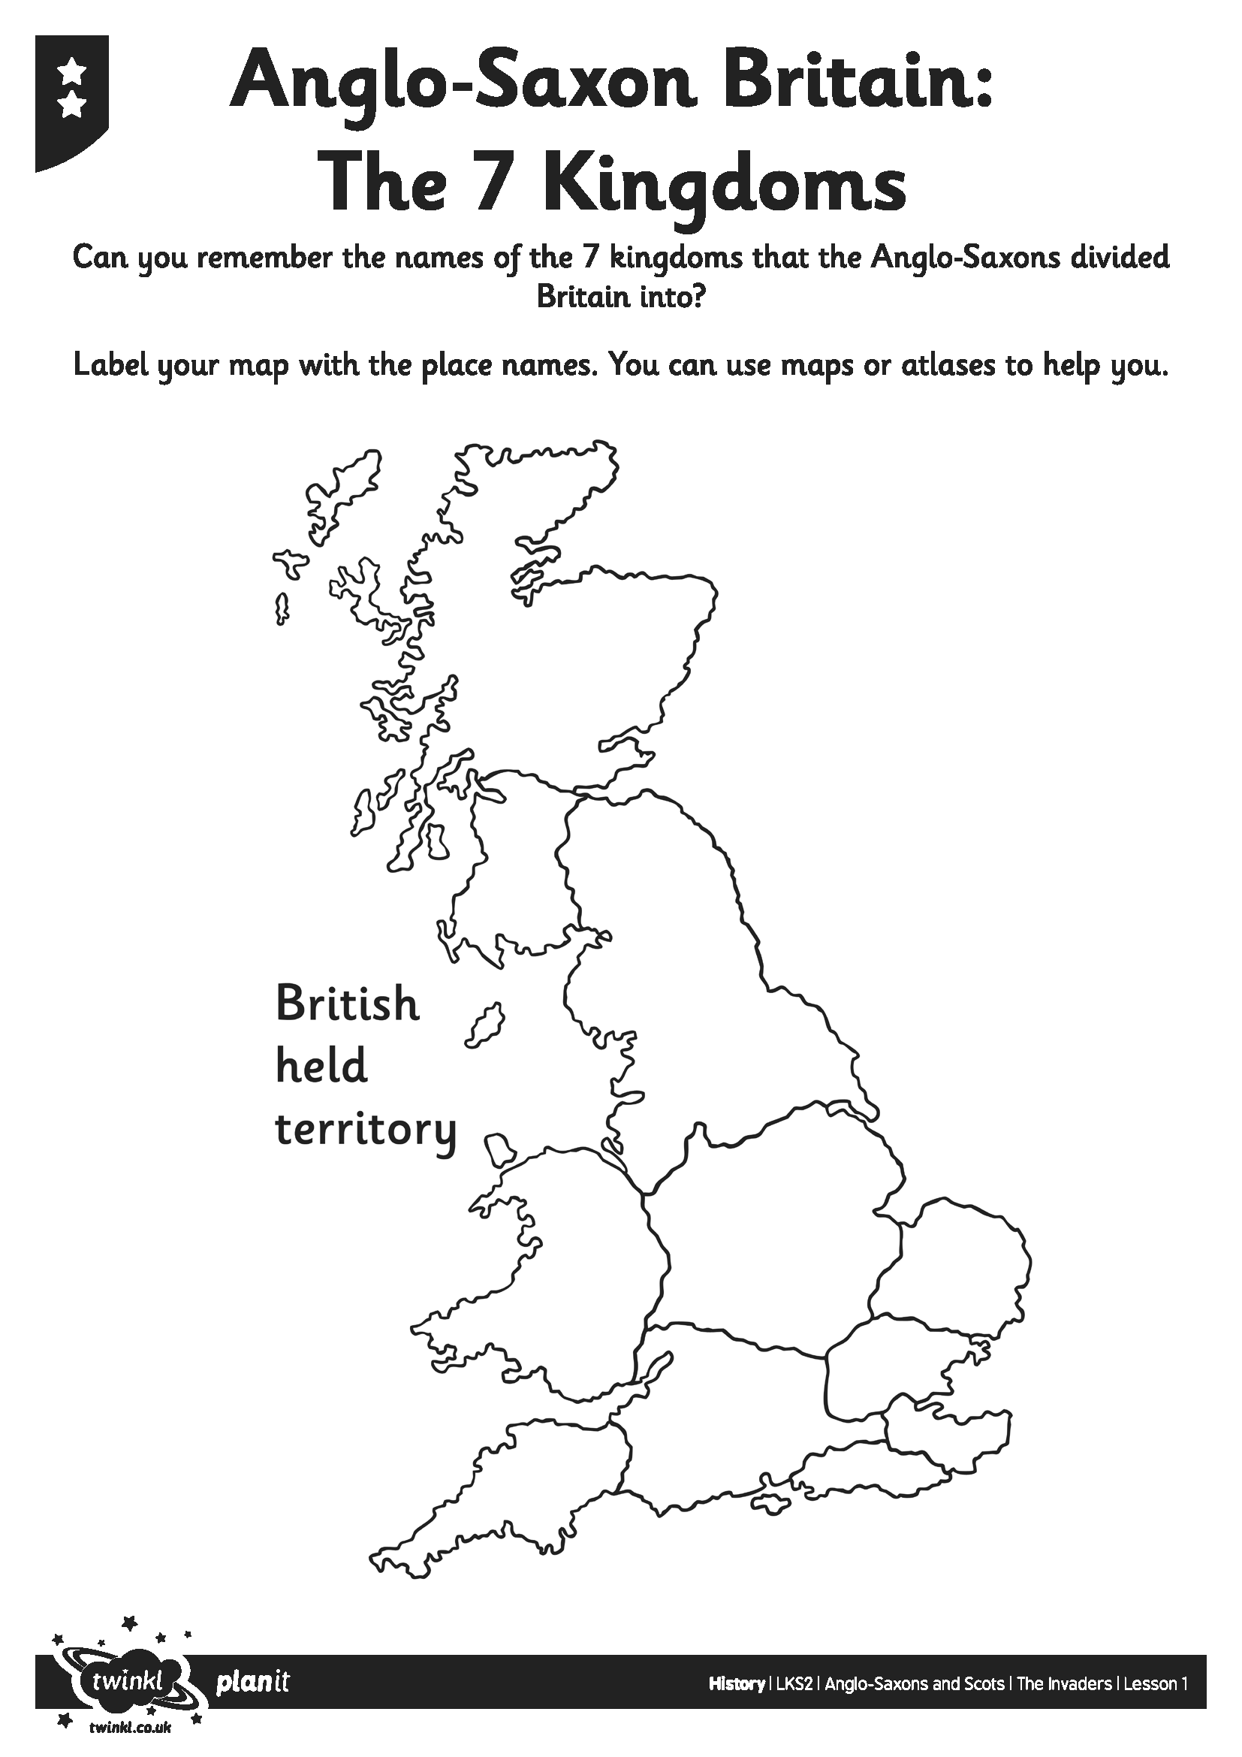
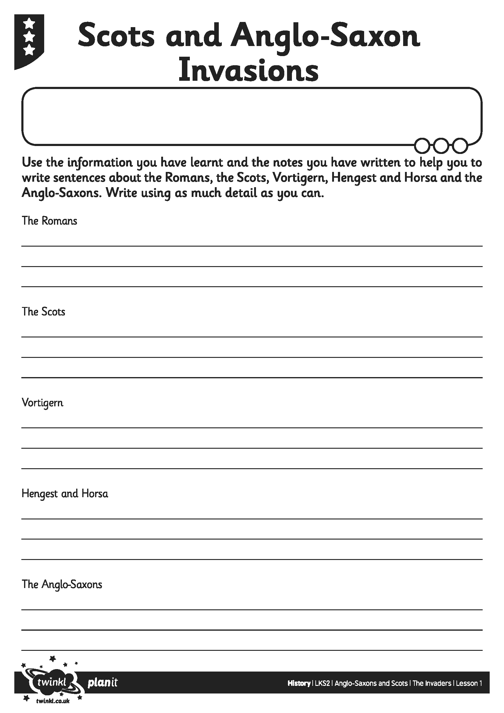
I can describe why, where and when the Scots and Anglo Saxons invaded Britain and explain what the seven Anglo Saxon kingdoms were.

