Children’s Art Week
29.06.20
Monday 29th June is the start of the Children’s Art Week (which actually lasts 3 weeks) so we just wanted to suggest some ideas that you could include in your home learning. Activities involving creativity really benefits children’s mental health and wellbeing; which is so important during the current circumstances.
- Engage- Bringing people together with art
If parents sign up below, children can access events, activities and workshops for children of all ages to encourage everyone to #GetKidsCreating. All events and activities are free to take part in and use simple materials that can be found around the house.
https://engage.org/happenings/childrens-art-week/for-families/

- Wild Art 2020 Competition with the RSPB
https://www.rspb.org.uk/fun-and-learning/for-kids/rspb-kids-competitions/wild-art/

- Jump Start Art
Has lots of art and ‘making’ projects.

- Daily Doodle
Can you doodle every day? Like a diary it might show how you are feeling each day or it might just be totally different each day.

- Outdoor Art
TTS have some great suggestions for outdoor art activities.
https://www.tts-group.co.uk/blog/2018/08/22/top-12-outdoor-art-ideas.html
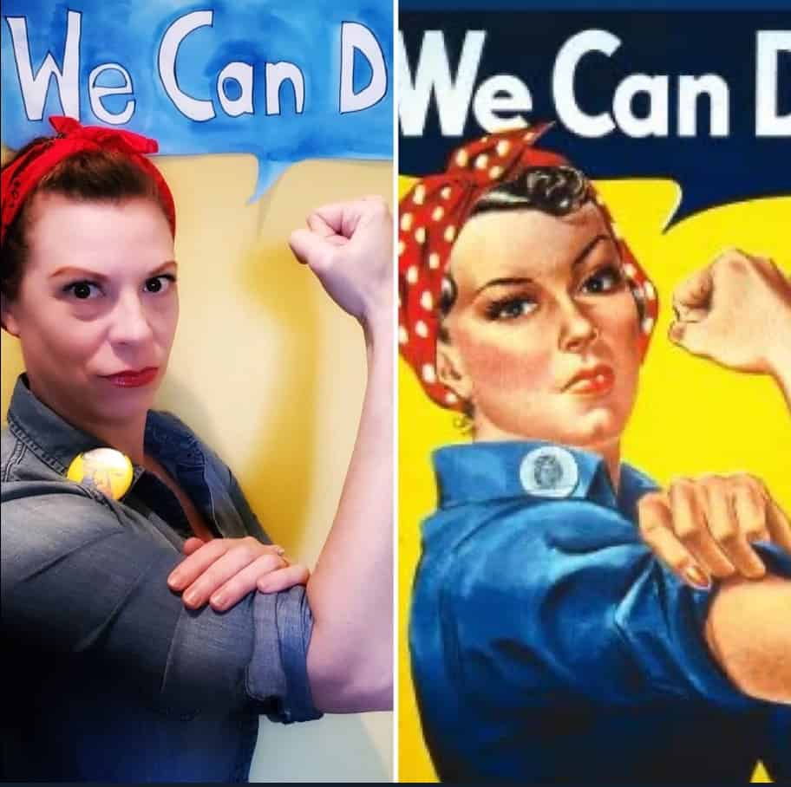
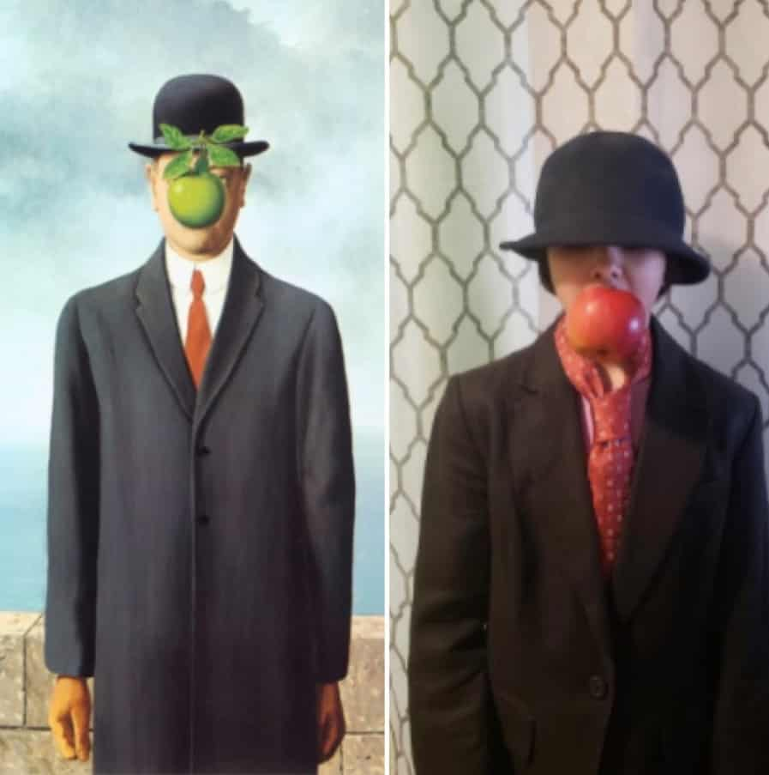
- Recreate a famous work of art

- Drawing YouTube channels
There’s a huge amount of drawing tutorials on YouTube for children. I’ve just linked a few below, but there are hundreds more!
Mark Crilley https://www.youtube.com/watch?v=tqhHYDTrp0Y
How To Draw Pokemon https://www.youtube.com/watch?v=f_vTg0MfHKI

