18.03.21
LO: To multiply and divide by 4.

- Match the multiplication to the representation.

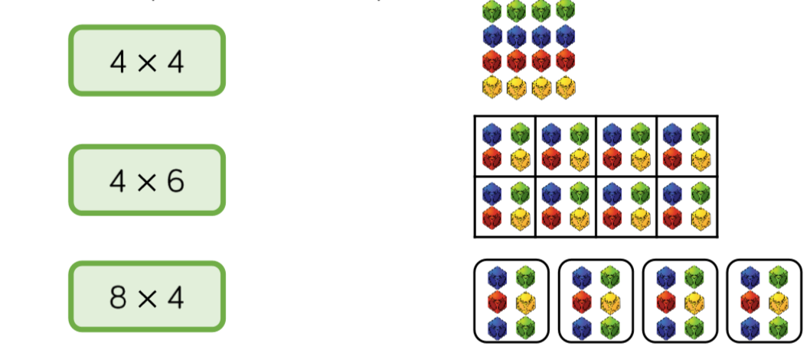

Star Challenge
