WC Monday 5th July
L.O. To research Olympic mascots.
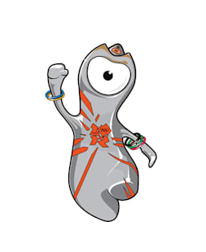 |  | 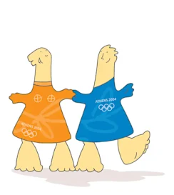 | 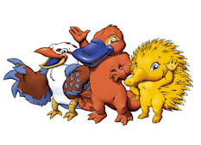
City: | City: | City: | City:
Year: | Year: | Year: | Year:
Name: | Name: | Name: | Name:
Description: | Description: | Description: | Description:
Did you know? | Did you know? | Did you know? | Did you know?

