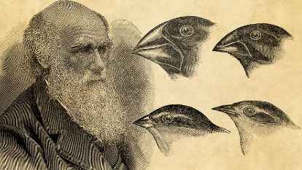
Spring 1 – Week 4
Guided Reading
- When was Darwin born?
- Who raised Charles Darwin?
- What profession did he first study?
- How many islands make up the Galapagos?
- What did Charles publish in 1859?

Spring 1 – Week 4
Guided Reading
- When was Darwin born?
- Who raised Charles Darwin?
- What profession did he first study?
- How many islands make up the Galapagos?
- What did Charles publish in 1859?

Spring 1 – Week 4
Guided Reading
- When was Darwin born?
- Who raised Charles Darwin?
- What profession did he first study?
- How many islands make up the Galapagos?
- What did Charles publish in 1859?

