Science skills Explaining Science | Me | Teacher
I use simple science words correctly to describe stages of the plant life cycle*
I begin to use some complex science words correctly to describe the functions of some stages of the plant life cycle **
I use complex science words with confidence to describe and explain the functions of different stages of the plant life cycle***
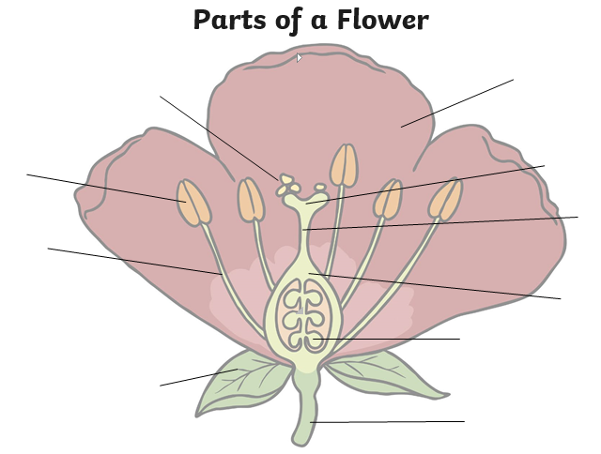

Science skills Explaining Science | Me | Teacher
I use simple science words correctly to describe stages of the plant life cycle*
I begin to use some complex science words correctly to describe the functions of some stages of the plant life cycle **
I use complex science words with confidence to describe and explain the functions of different stages of the plant life cycle***

