English
Lesson 1 - Monday 20th April
New vocabulary
soaring, colossal, flicker (of light) and immense
Can you use a dictionary or the internet to find the meaning to these words?
After, have a go at using each word in a sentence and write your sentences down.
e.g. The ancient oak tree was colossal compared to the other, smaller trees.
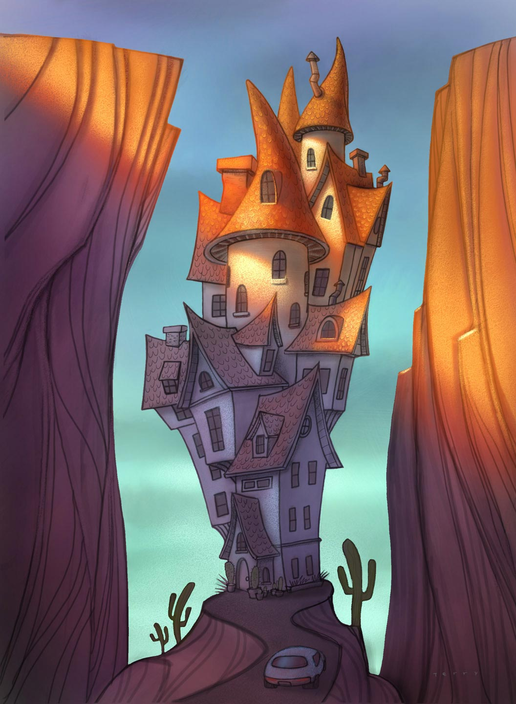
Lesson 2 - Tuesday 21st April
Generating vocabulary from an image
Look at the image and just generate words and phrases to describe the image. Think about; who might live there? Where might this be? Who is in the car? Why is it built between to cliffs?
Can you come up with any similes? e.g. As tall as a giant.
Record your ideas and if you can, why not use a thesaurus to improve some of your vocabulary choices.

Lesson 3 - Wednesday 22nd April
Descriptive sentences
Now that you have lots of ideas and you have generated some super vocabulary, you can you start to write some descriptive sentences.
e.g. The windy road leads to a towering house perched between two tall cliffs.
REMEMBER – read through your writing carefully. Have you got capital letters? Have you got full stops, commas, exclamation marks and question marks (if they are needed)?

Lesson 4 - Thursday 23rd April
Can you explain write about who lives in the house? Tell me about this character? Why they have chosen to live there and what can be found inside their towering home.

