LO: To understand the reasons for WW2 and place some key events in chronological order.
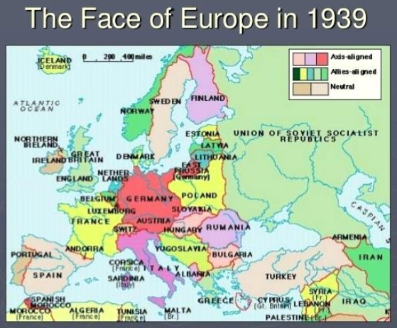

LO: To understand the reasons for WW2 and place some key events in chronological order

