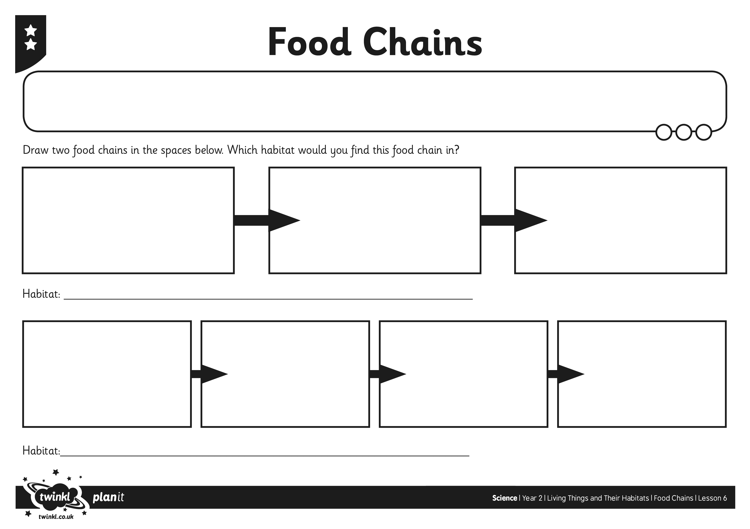
I can use a food chain to show how animals get their food.

