Monday 1st March

LO: To be able to identify three different settlement patterns.

Match the correct terms to their definitions and accompanying maps.

Settlements where few buildings are spread over a large area

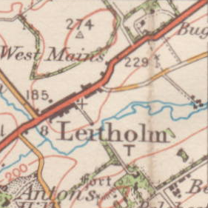

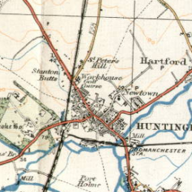

Linear  
Settlement

Settlements centred around a focus point, such as a bridge or major crossroads

Dispersed  
Settlement

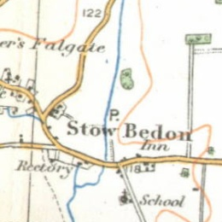

A settlement based in a narrow band along a road or other feature

A settlement based in a narrow band along a road or other feature

Nucleated Settlement

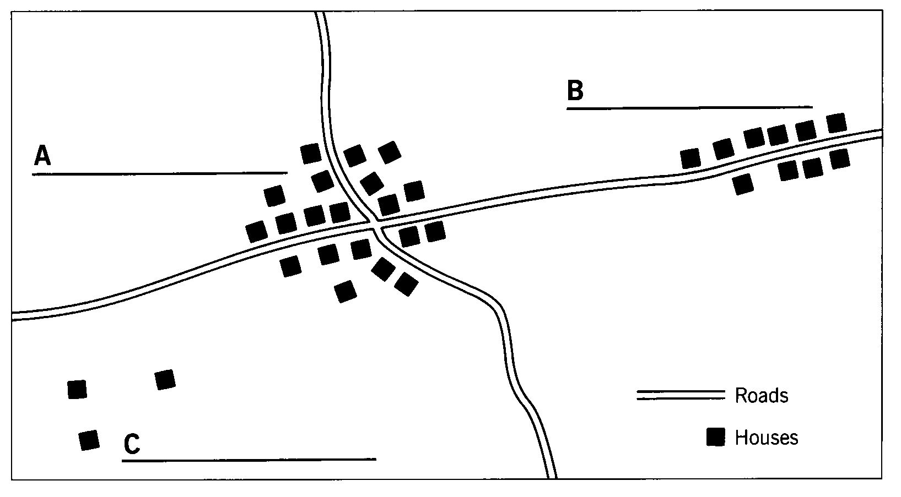

Nucleated Settlement