11/3/21
LO: To identify lines of symmetry

- Each shape shows a vertical line of symmetry. Complete each shape.
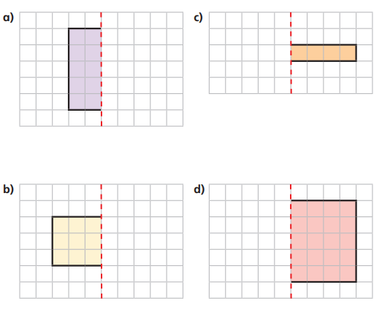

- Rosie has completed this shape.
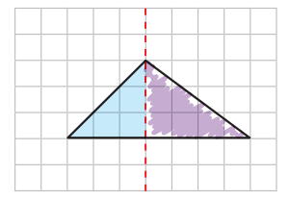
What has she done wrong? Can you complete the shape correctly?
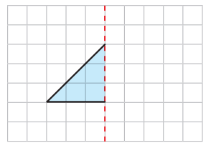

- Complete these shapes.
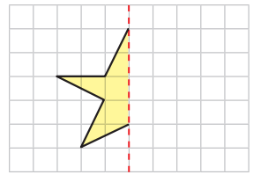
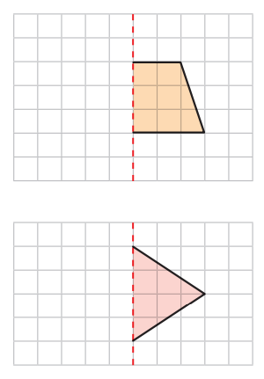

- Complete this picture to make it symmetrical.
