LO: To learn to write Instructions
Here is a copy of the text we have been learning and an example text map:

How To Make Turkish Delight
The sticky, soft, chewy sweet is usually incredibly floral with the flavours of rose water or orange blossom... but this version takes a green twist with Pandan extract and elderflower. Whether you know of it from Narnia or street markets and stalls across Europe and North Africa... when dusted in icing sugar and cornflour everybody want a square!
Ingredients
- 850 ml cold water
- 800 g caster sugar
- 1/4 lemon (juiced)
- 160 g cornflour
- 1 tsp cream of tartar
- 2 tbsp elderflower cordial
- 1 drop pandan extract
- 1 handful pistachio nuts
- 120 g icing sugar
- 30 g cornflour

Method
- First, dissolve the caster sugar into 350ml of the water and the juice from the quarter of a lemon in a deep saucepan over the stove. Carefully heat until the mixture reaches 118°C then take off of the heat.
- Next, dissolve the cornflour and cream of tartar in the leftover 500ml of cold water in a separate saucepan then heat to a boil as you whisk. As the mixture thickens, keep stirring slowly.
- Then, pour the sugar syrup into the cornflour paste slowly but surely, mixing well as you do it. It might go lumpy, but keep whisking. Heat very gently (as low as it’ll go) for an hour by which time you’ll have a thick, slightly golden syrup.
- After that, stir in the cordial and pandan, then mix in the pistachio nuts. Transfer to a lined and deep roasting tin (20cm x 20cm) and allow to cool and set for several hours.
- Finally, toss the icing sugar and cornflour together in a bowl. Cut the set Turkish delight into pieces and dust in a combination of the icing sugar and cornflour then serve or store in an airtight container.

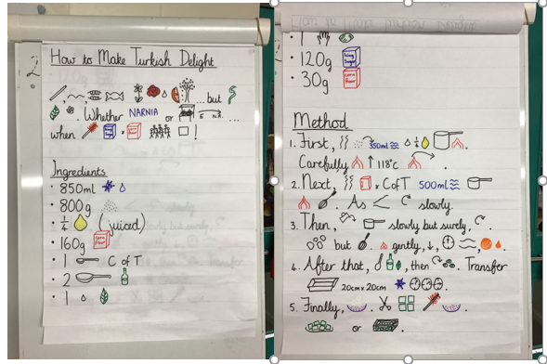

Monday – Follow a set of instructions
Find a recipe at home either from a cook book or online and follow the recipe to make the item.
Can you spot the features of an instruction text? e.g.
title
ingredients
method
imperative (bossy) verbs e.g. cut, chop, mix
adverbs e.g. carefully, gently
bullet points or numbered steps in order

Why is this so important? Watch this short video to find out!

https://www.bbc.co.uk/bitesize/clips/zb43cdm

Tuesday – Layout and friend poem
Look at the layout of the example instructions at the beginning of this booklet and answer the following questions.
Why is there a title at the top?
Why are the ingredients written before the method?
Why are the method steps numbered?
What is the importance of the measurements in the ingredients section?

Think about the type of measurements there are, some are the capacity of a liquid, some are the weight of an item and others are measured using different types of spoons.
Can you sort the measurements from the text into the following groups? (some have been done for you). Can you think of any other measurements that you could add to the groups?
Capacity -  Measurements for liquid e.g. millilitres (ml) | Weight -  Usually for dry items in a recipe e.g. grams (g) | Spoons or Cups -  Can be used for liquid or dry items e.g. 1 desert spoon (dsp) | Fractions -  Part of an item e.g. half | Other -  These measurements are a bit more vague
ml |  | dsp |  | sprinkling  splash  dollop  squirt  dash
Friend poem.
Think about what makes a good friend. Here are some ideas to help you:
kindness, love, helpfulness, knowledge, fun, listening, eye-contact, sharing, caring, smiles, encouragement, growth-mindset, friendliness, empathy, enthusiasm, consideration, patience, respectfulness, laughter, humour

Choose the things that you think are most important in a good friend from the list above, or think of your own. Then write a poem using a variety of measurements for the ingredients for a good friend. Here is one I have done…

Ingredients For A Good Friend

A huge dollop of listening,
3 tbsp of caring,
A bucketful of humour,
100g of smiles,
1 kg of encouragement,
A sprinkling of sharing,
A squirt of fun,
50ml of kindness,
1 level ladle of love.

Wednesday – Ingredients for revolting sandwich
We have received another letter, this time from the head chef at the castle. We have given you a copy below. Do you think we can help him?

Hello again sons of Adam and daughters of Eve,
Thank you so much, we kindly received your instructions on how to make Turkish delight. We know how hard you have been working to learn these instructions.
Things aren’t getting any better at the castle, the White Witch is horrible to us. She’s evil. We’ve been thinking of ways to play our own tricks on her, to try and get our own back.
She’s now throwing a royal ball and we’re in charge of making ALL the food but there are just not enough hours in the day. She said we will be punished if we don’t make everything in time. So, we were hoping for a little more help from you. Do you know how to make a sandwich? Some of our servants have never worked in the kitchen before and don’t know how to make one. I was wondering if you could write a set of instructions telling them how to make a sandwich. It would be of great help.
Maybe you could send us recipes for revolting sandwiches? That would certainly trick her, as she wouldn’t be expecting that!
Thank you so much sons of Adam and daughters of Eve, we couldn’t have done this without you.
Yours sincerely,
Hogglestock (head chef at Cair Paravel, Narnia)

Your task today is to write the first part of your instructions for a revolting recipe. Today you are going to write the title and make a list of ingredients for a revolting sandwich. Don’t forget to include all your measurement vocabulary. Remember to use your neatest handwriting so that the head chef can read it.

Please look at the word mat attached to the home learning page to help you with spelling and with choosing words to use.

Here are some ideas. I bet you can think of lots more revolting ingredients! Make sure they are really revolting!

2 slices of stale bread
½ tablespoon of red ants
1 cup of mouldy bubble-bath mayonnaise

Thursday – Method for revolting sandwich
Today you are going to write the method for your revolting sandwich. Use word mat attached to the home learning page to help you with spelling and with choosing words to use.

Remember to include:
- numbered points in order
- time connectives: First, Next, Then, After that, Finally.
- imperative verbs e.g. spread, chop, mix
- adverbs e.g. carefully, gently, neatly

Once you have finished your instructions for how to make a revolting sandwich, please pop a copy of it on Seesaw so we can send it to the head chef at Cair Paravel, Narnia.

I’m sure he will be very pleased!

