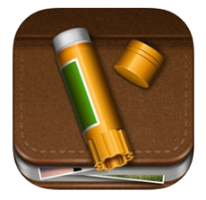
Thursday 1st October

LO: Look at a selection of eBooks and decide what makes them engaging.
LO: Plan and design own non-fiction eBook.

Front cover: | Page 1:
 | Page 2:

Page 3: | Page 4:
Page 5: | Page 6:

