- True or false.
7 × 6 = 7 × 3 × 2

7 × 6 = 7 × 7 + 8

- Amir has £1,000
He buys a scooter for £345 and a skateboard for £110. How much money does he have left?
Show 3 different methods of finding the answer.

- Can you complete the calculations using some of the symbols or numbers in the box?
$$÷$$
$$=$$
10
100
9
900

____ ÷ ____ = 9
90 = 900 ____ 10

- Always, Sometimes, Never

If a number is a multiple of 3 it is also a multiple of 6

Explain why you think this.

- 1,235 people go on a school trip. There are 1,179 children and 27 teachers. The rest are parents.
How many parents are there?

- What is the missing 4-digit number?
 | TH | H | T | O
 | ___ | ___ | ___ | ___
+ | 6 | 3 | 9 | 5
= | 8 | 9 | 4 | 9

- If 6 × 12 = 72 then 12 ÷ 6 = 72.
Is this correct?
Explain your answer.

- Choose from these 4 cards. Using any symbols, can you make these numbers:
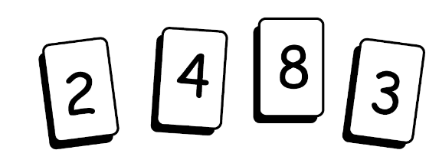
9
10
11
12
13
14
15

