Summer 1 Week 3: Timetable Ideas
Down in the Jungle Week
 | 9.00 – 9.30 | 9.30 – 10.30 | 10.30-11.00 | 11.00 – 12.00 | 12.00 – 1.00 | 1.00 – 2.00 | 2.00 – 3.00
Monday - Friday | Exercise  See the options below under ‘exercise’ | Phonics  DAILY:  RWInc Set 2 Lesson at 10 am  https://www.youtube.com/channel/UCo7fbLgY2oA_cFCIg9GdxtQ  Practise red and green words from pack  Read RWInc. Text on Oxford Owl website (see individual Tapestry posts)  Daily caption writing (see below) | Break & Snack time | Maths  See further guidance under ‘maths’ below | Lunch | Down in the Jungle  See further guidance under ‘Down in the Jungle’ below | Daily walk / play in the garden / free play

Exercise
- Down in the Jungle song and dance
https://www.youtube.com/watch?v=-zxcGKIMcOs
- Jamie’s Jungle Brain Break
https://www.youtube.com/watch?v=dKa2LHYcln4
- Try this Jungle HIIT session
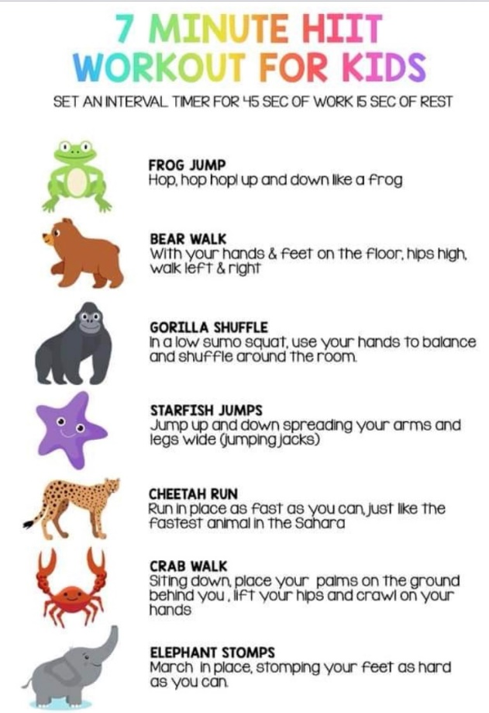
Maths
This week we will be using the Numberblocks to help us with our maths work
- Monday – looking at the number 14 https://www.youtube.com/watch?v=xjGIx5f4uYg try putting your number cards in order up to 14. Can you find 14 objects to match the number card 14? Notice that 14 is made up of 10 and 4.
- Tuesday – put your number cards on the floor, can you splat the number your grown up calls out?
- Wednesday – looking at the number 15 https://www.youtube.com/watch?v=8g4N6aSTYy4 try putting your number cards in order up to 15. Can you find 15 objects to match the number card 15? Notice that 15 is made up of 10 and 5.
- Thursday – watch the Numberblocks episode about pattern https://www.youtube.com/watch?v=U__EFzinbA8 can you find anything with repeating patterns in your house?
- Friday – make a repeating pattern snake (see template) using two or three colours. You could use paint, felt-tips, pencils or blocks.
Down in the Jungle
- Monday:
Listen to the book Rumble in the Jungle
https://www.youtube.com/watch?v=D2-O1LkCzpM Have you got any other Jungle books in your collection at home that you can have a look at?
- Tuesday:
Look at the animal handprint pictures below. Could you make a jungle animal handprint?
- Wednesday:
Do some research using books or the internet with a grown up and find some interesting facts about a jungle animal of your choice. Can you make a fact file about your animal by writing some interesting sentences and drawing a picture?
- Thursday:
Listen to the story of Gerald the Giraffe https://www.youtube.com/watch?v=Zzb5Acl-n70 Ask your child questions about the story at the end and emphasise the importance of not giving up if we find something tricky. What did Gerald find tricky? Were the other animals kind to Gerald? Why not? Did Gerald give up or did he keep on trying? Could Gerald dance in the end? What things do you find tricky? How could you get better at those things?
- Friday:
Try doing the jungle rain cloud experiment (see attachment) What do you think is going to happen to the coloured water? Did it take a long time for it to start ‘raining’? Where does the coloured water come through the cloud quickest? Is it near the edge of the glass or in the middle?
To finish off your week try Andy’s quiz to find out how much of a jungle expert you are!
https://www.bbc.co.uk/cbeebies/puzzles/andys-safari-are-you-a-safari-animal-expert
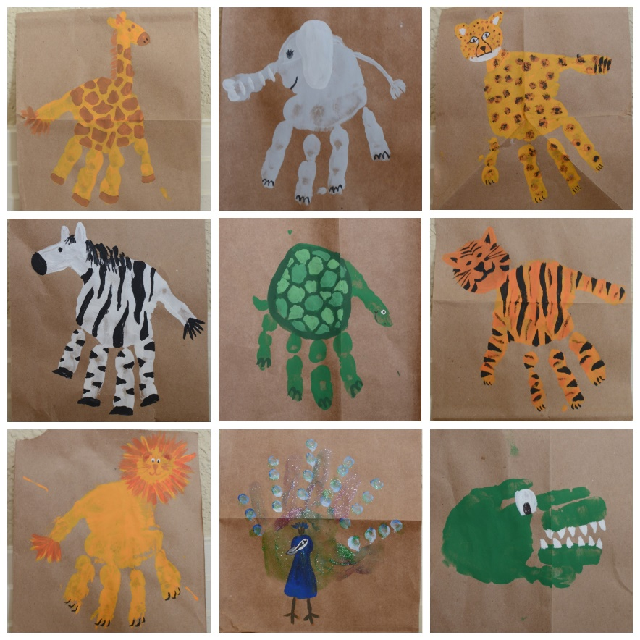
Caption writing
Write a caption to match each picture, for example, A cat in a hat.

