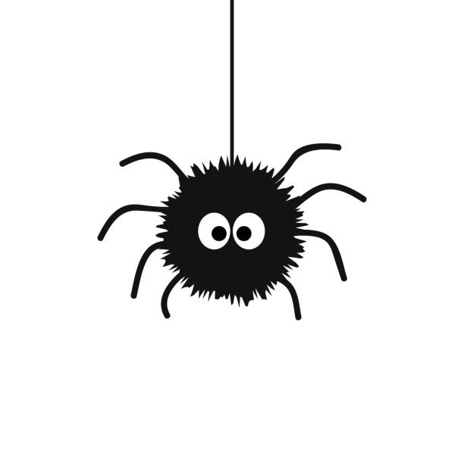
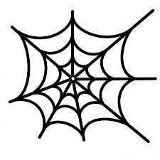
Nursery Home Learning
Week Beginning Monday 11th May

The Very Busy Spider

Spider themed stories

Start the week with the story ‘The Very Busy Spider’ and other spider themed stories.

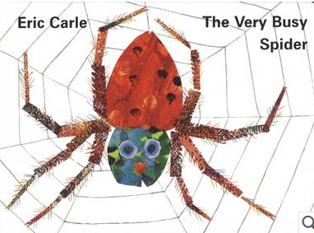  https://www.youtube.com/watch?v=nEPYKmIt4dU | 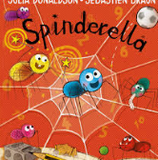  https://www.youtube.com/watch?v=9639_WmGRLk
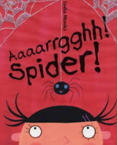  https://www.youtube.com/watch?v=5df388jmToo | 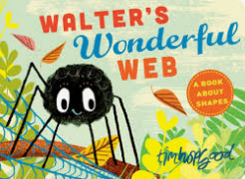https://www.youtube.com/watch?v=AQ9MK2zqvOw

Get moving
We were very excited to learn that the Gateshead School Sports Partnership were so disappointed that the Gateshead Dance Festival couldn’t go ahead, they have organised a virtual festival! They have tutorials each day, finishing with a performance on Friday. Record and upload your dance to Tapestry.
What it’s all about
https://www.youtube.com/watch?v=XJtwt_lzt-U&list=PL8sjgfNYFn6A-afci0ooJjlWaC6IvfmFF&index=7&t=0s
The dance
https://www.youtube.com/watch?v=OxKchFf8gdY&list=PL8sjgfNYFn6A-afci0ooJjlWaC6IvfmFF&index=6&t=0s
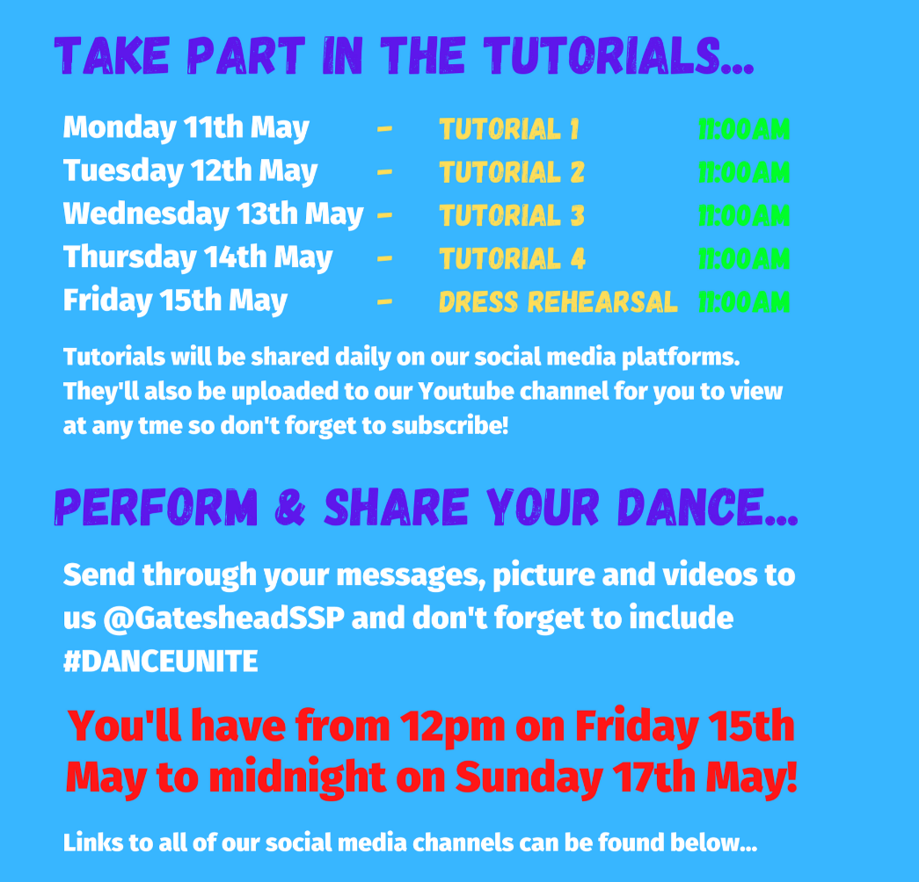
Cosmic Kids Spider Power yoga compilation
https://www.youtube.com/watch?v=fnO-lGEMOXk
Maths
Use the ‘White Rose’ website:
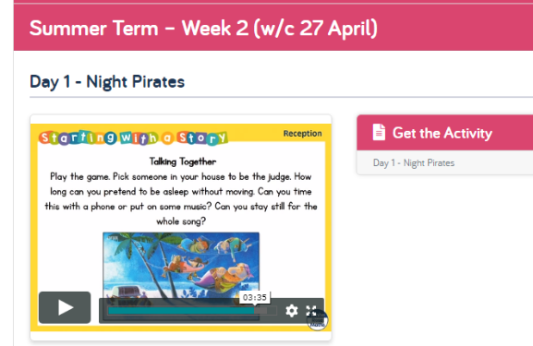
https://whiterosemaths.com/homelearning/early-years/
There is a home learning section for Early Years. If you find the section for this week, all of the activities are based around the book The Very Busy Spider.

Each day there are different activity ideas which can all be done without the books. Each day begins with a 5-minute video to watch. The video starts with the ‘days of the week’ song which the children should know!

Singing
- Incy Wincy Spider
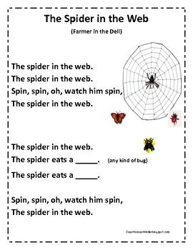
- The Spider in the Web

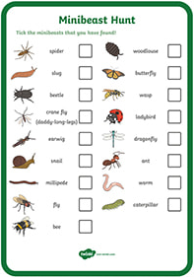
Mini beast hunt
Go on a mini beast hunt with your family and see how many spiders, webs and other mini beasts you can find. Tick these off on your mini beast checklist. (Resource on Tapestry and Emmaville website.)

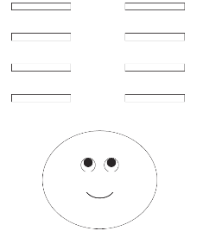
Cut and Stick
2D Shape spider Cutting Skills- colour and cut the 2D shapes then stick them on the web to make a spider. (Resource on Tapestry and Emmaville website.)

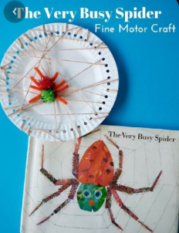
Other ideas…

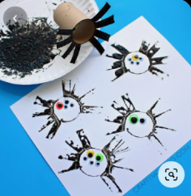
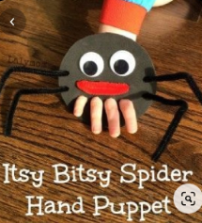
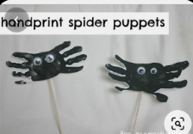
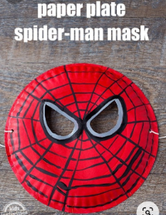
Cooking
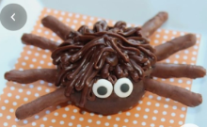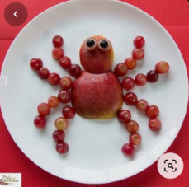

Sensory play/ fine motor

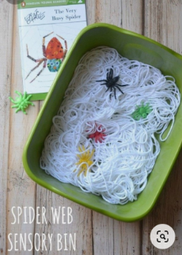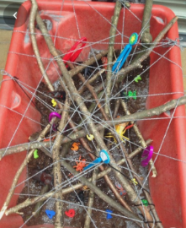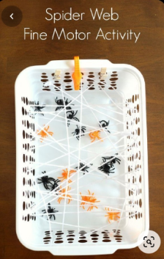

Phonics
- Letters and Sounds website phase 1 Listening games:
http://www.letters-and-sounds.com/phase-1.html

- Use the 30-day free trial at Reading Eggs to practise listening games and phonics / letters games:
https://readingeggs.co.uk/

Remember these are all just ideas, please do not feel like you have to do all of them.
Keep reading lots of books, singing songs and nursery rhymes and encouraging as much mark making with pens, pencils, paint, chalks and crayons as possible.
Keep in mind that with young children, it’s all about the process, not the product. It doesn’t really matter what the finished result looks like!
Most importantly… Have a fun week!

