Friday 2nd July 2021

Dear Aunty Susie,
Thank you very much for the present you sent me for my eighth birthday. I love the hat!
We had a fun day with my family and friends. We played party games and ate yummy food. Mum made me a rainbow cake with eight candles on the top!
I hope you are well and I can’t wait to see you again soon.

Lots of love
Ella

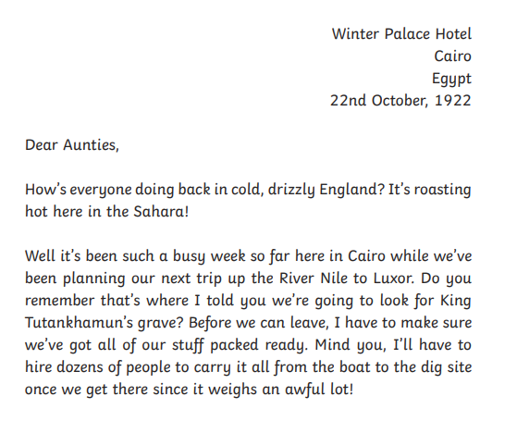
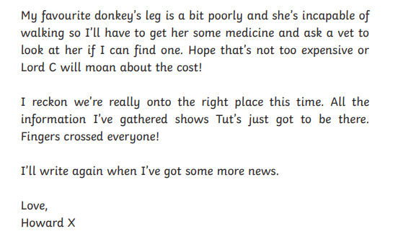

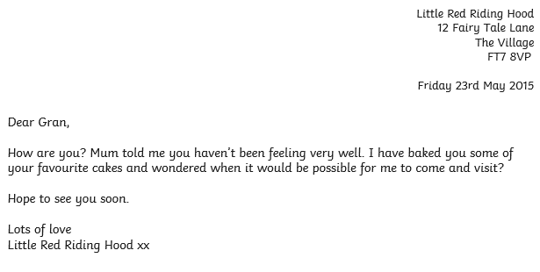

Dear Daisy,
How are you? We are at the seaside!
It has been like a dream and very nice weather too. What a treat! We have had ice cream every day and my Mum said maybe I can go on a donkey tomorrow and she will teach me to swim, what a week it’s been! We’ve spent lots of money as it isn’t cheap and our feet are tired but it’s been worth it.
Lots of love and see you soon.
May xx

