Week 7

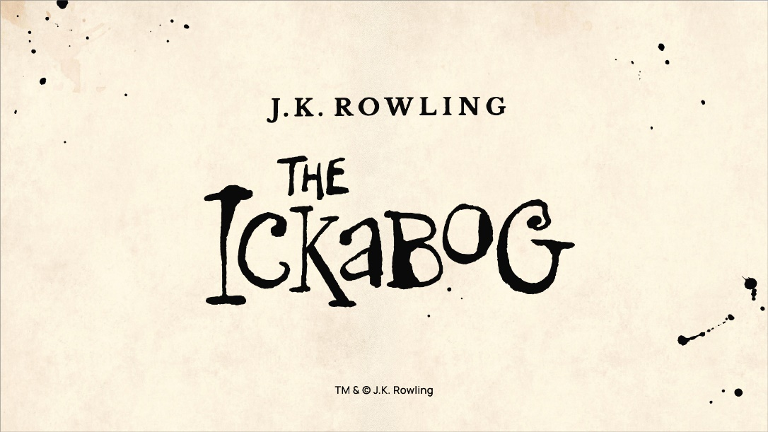
https://www.jkrowling.com/j-k-rowling-introduces-the-ickabog/
Use the link above to continue to read JK Rowling’s new book.

This is the website: he Ickabog website (you can use this link to go to that website.)

Really exciting news: JK Rowling has decided that she wants her book to be illustrated by children during lockdown. We want you to spend time over the next seven weeks, reading the story and completing some illustrations which we would love for you to enter into the illustration competition. At the end of the week you can post your illustrations for the competition. I would love to see someone from Emmaville School with an illustration in her book. Good Luck
We would love to see some of your ideas and pictures on Seesaw too.
Spend time looking at the links above this week and make sure you find out more about the book and competition for yourselves. The competition launched on the 26th May and there is a page on the Ickabog website:
https://www.theickabog.com/info/the-ickabog-illustration-competition-is-launched/
that gives ideas of what you could illustrate for each chapter.
We think is a unique opportunity for all of those creative and arty people. We hope you enjoy this work and look forward to seeing what you produce. Have fun Year 4.

