11/3/21
LO: To identify lines of symmetry

- Tick the shapes that have a vertical line of symmetry.
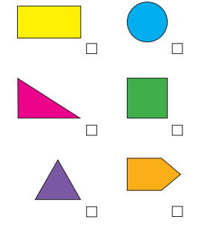

- Draw the vertical line of symmetry on the shapes.
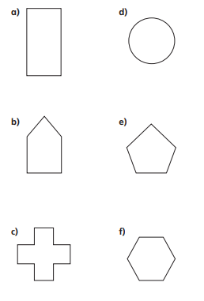

- Annie is drawing a vertical line of symmetry on some shapes. Tick the ones she has completed correctly.
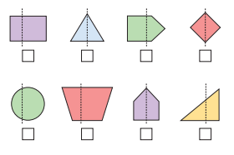

- Draw a six sides shape which has a vertical line of symmetry.
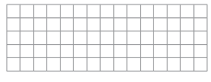

- Complete the shapes and write how made sides and vertices each shape has.
