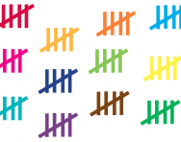
LO: To collect and record data using a tally chart

Answer | Tally | Total

