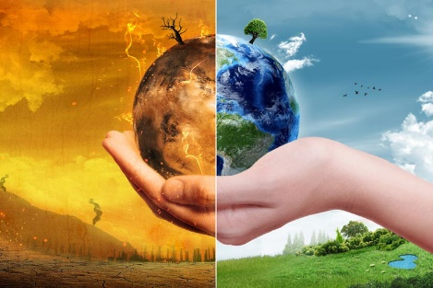
Geography Task – Week 4.

We are looking at climate change/global warming over the next few weeks.
Your task this week is to make a glossary of words associated with global warming and climate change.

  - First, you need to sort the following words into alphabetical order.
The words that you need include in your glossary are:
Weather, climate, deforestation, methane gas, pollution, habitat, carbon dioxide, endangered and ocean circulation.

  - Next, you need to use a dictionary or an online dictionary to find definitions of the words.
  - Read the definitions through, making sure you understand them. (If you don’t then talk through the words and meanings with an adult).
  - Then you need to write a definition in your own words, making sure you write these in alphabetical order.
  - Each new word should be written on a new line, followed by the definition.

Hopefully at the end of this task, you will feel that you have a better understanding of the words associated with climate change.

I look forward to reading your glossary. Good luck
