06.10.20
L.O. I can add using 10s and 1s.
1) Use Base 10 to complete the part – whole model.
Complete the sentences:
There are tens and ones.
The whole is
+ =
2) Complete the sentences to describe each number:
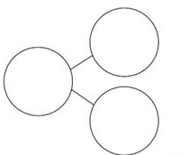
4) Sophie has 30 Lego bricks and Noah has 28 Lego bricks. Represent the total number of Lego bricks.

3) Complete the number sentences.
The first one has been done for you.

+ =
5) Complete the part whole models. Write 4 number sentences to match.

6) Complete the number sentences.
You might want to use Base 10 and a part-whole model to help you answer these questions.

