25.03.21
LO: LO: To use knowledge of multiplying and diving by 8 to become more confident with the 8 times table.

- Complete the table.
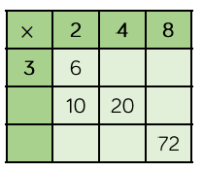
Can you spot a pattern between the numbers?

Colour the multiples of 8 red and multiples of 4 blue.
Always, sometimes, never.
- Multiples of 4 are also multiples of 8.
- Multiples of 8 are also multiples of 4
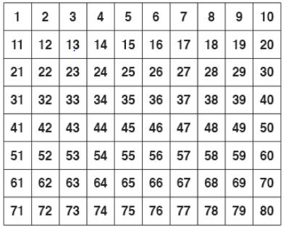

Star Challenge
Find all the matching answers.
