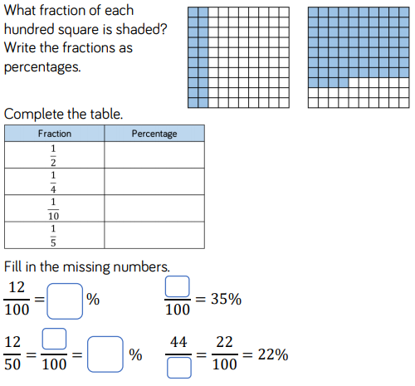
LO: Converting Fractions to Percentages

LO: Converting Fractions to Percentages

LO: Converting Fractions to Percentages

LO: Converting Fractions to Percentages

