20.01.2022
L.O I can subtract numbers up to 20 by counting back.
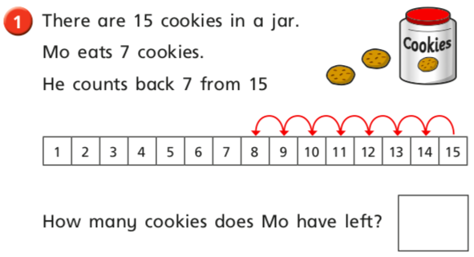
1.

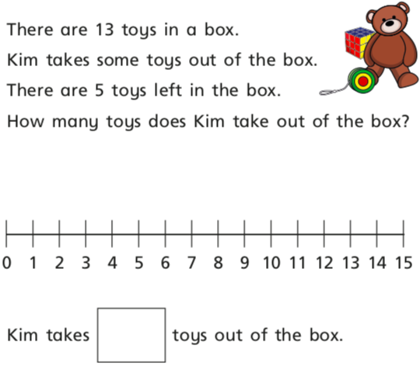
2.

