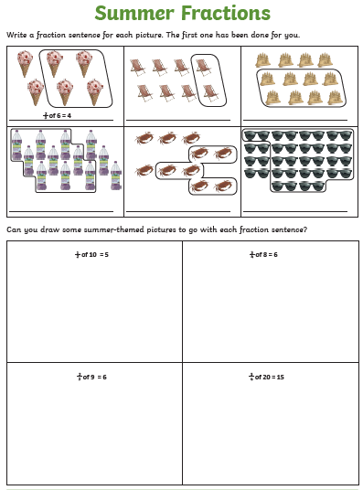

Fractions, decimals and percentages
https://nrich.maths.org/1249

