Friday 27th November 2020
LO: Use fraction strips to add and subtract Fractions
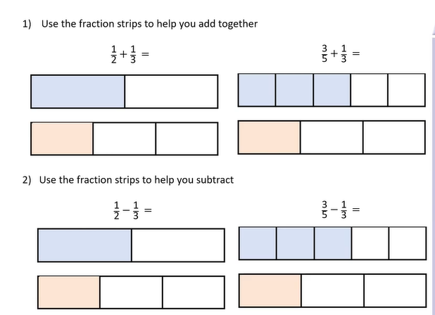
You will need paper, cut into strips, and a ruler.

Challenge your partner with an example of adding and subtracting fractions of your choice.

