WC 15/3/21
LO: To understand how medicines work in my body
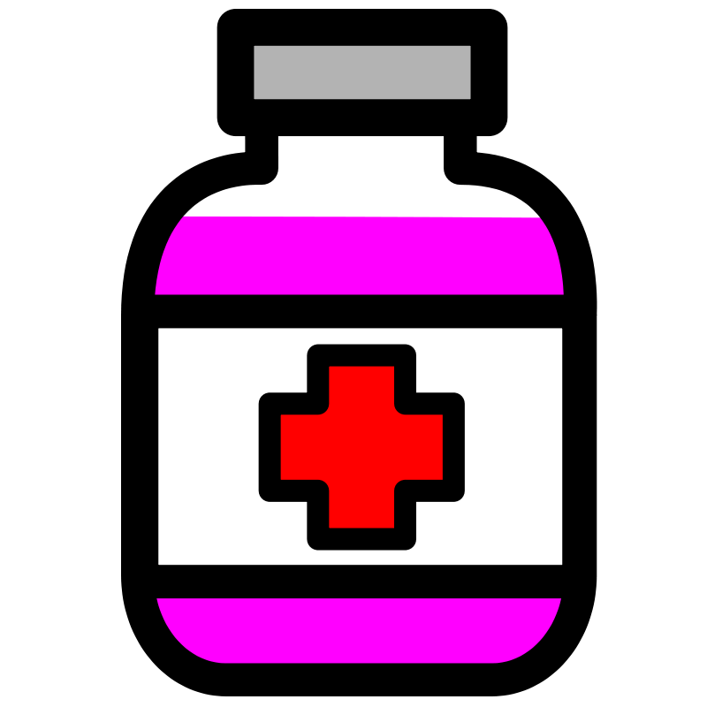
If we are feeling poorly, there are lots of things we can do to help us feel better such as having a drink or getting some fresh air.
Sometimes, we need to take some medicine to help us to feel better, but we know we have to keep ourselves safe when taking medicine.

Two things I can do to keep myself safe when taking medicine:
1.
2.

