Summer 2 Week 2 29 June 2020 Timetable Ideas
 | 9.00 – 9.30 | 9.30 – 10.00 | 10.30-11.00 | 11.00 – 11.30 | 11.30-12.00 | 12.00 – 1.00 | 1.00 – 1.30 | 1.30 – 3.00
Monday - Friday | Exercise  Joe Wicks workout  Go Noodle  Cosmic Yoga | Phonics – Reading  See below. | Break & Snack time | Independent activities  Drawing, writing, reading, colouring, Lego etc…  Writing  See below. | Maths  Oak National Academy  Week 10, WB:- 29 June.  Measures Focus: Capacity, volume, weight and length  https://classroom.thenational.academy/schedule-by-year/reception | Lunch | Music activities  Out of the Ark:  https://www.outoftheark.co.uk/ootam-at-home/  Gateshead Music Service  Facebook Session.  Storytime  Storytime with Nick  https://www.youtube.com/channel/UCo7fbLgY2oA_cFCIg9GdxtQ | Art:-  Children’s Art Week  A range of activities to choose from!  See Below.  PHSE:-  Talk about….  Returning to School.  Please see document attached.

Phonics / Reading /Writing

Every day:
See Tapestry for more detail.
- New RWInc Set 2 Lessons
https://www.youtube.com/channel/UCo7fbLgY2oA_cFCIg9GdxtQ
- New RWInc. Read Red Words 1 Film or RWInc Read and Hold a Sentence 1 Film or Speedy Green Words Slide Show (Oxford Owl)
- Read RWInc. text Oxford Owl.
- Read a text from Epic – free on-line library. https://www.getepic.com/students Please see Tapestry for Class Code Info.
- Write a sentence or two at some point during the day.
You could use the ideas from Read and Hold a sentence or follow the English lessons on
Oak National Academy, https://classroom.thenational.academy/schedule-by-year/reception Week 10, 29 June

Other tasks:
- Revise Set 1 sounds.
- Sing the Alphabet song to learn the names of the letters.
- Read, write and match: - upper and lowercase letters
- Read and write ‘green’ words.
- Read and write ‘red’ words.

Art -ideas
- Take photograph of the results of the Milk Mixing Colours activity on Friday 3 July Foundation Lesson on Oak National Academy.

- Engage- Bringing people together with art
If parents sign up below, children can access events, activities and workshops for children of all ages to encourage everyone to #GetKidsCreating. All events and activities are free to take part in and use simple materials that can be found around the house.
https://engage.org/happenings/childrens-art-week/for-families/

- Wild Art 2020 Competition with the RSPB
https://www.rspb.org.uk/fun-and-learning/for-kids/rspb-kids-competitions/wild-art/

- Jump Start Art
It’s a series of 50 ‘making’ projects for children during lockdown.

- Daily Doodle
Can you doodle every day? Like a diary it might show how you are feeling each day or it might just be totally different each day.

- Outdoor Art
TTS have some great suggestions for outdoor art activities.
https://www.tts-group.co.uk/blog/2018/08/22/top-12-outdoor-art-ideas.html
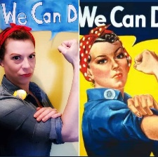
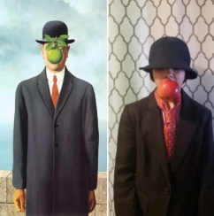
- Recreate a famous work of art

- Drawing YouTube channels
There’s a huge amount of drawing tutorials on YouTube for children. I’ve just linked a few below, but there are hundreds more!
Mark Crilley https://www.youtube.com/watch?v=tqhHYDTrp0Y How To Draw Pokemon https://www.youtube.com/watch?v=f_vTg0MfHKI

