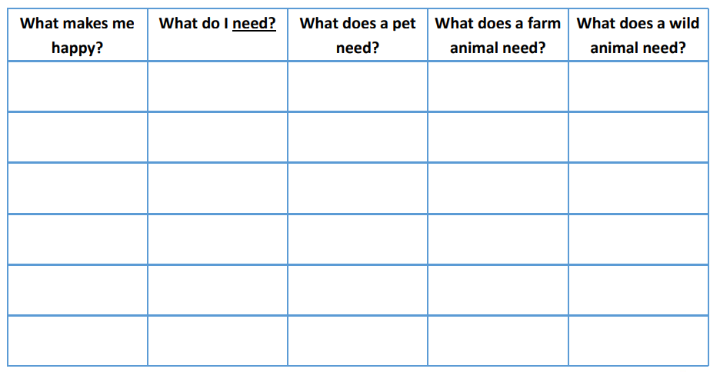

WC 10.01.22

L.O: To explore the basic needs of animals, including humans.