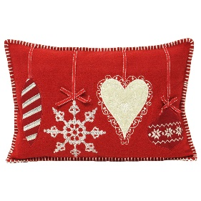
Thursday 2nd December
LO: To design and sew a Christmas cushion.
What will I need:  __________________________________________________  __________________________________________________  __________________________________________________  __________________________________________________ | Design plan:
Photo of finished design:

