Thursday 25th March
LO: To write sentences to explain
How do you think the dragon machine works? What do the different parts do?
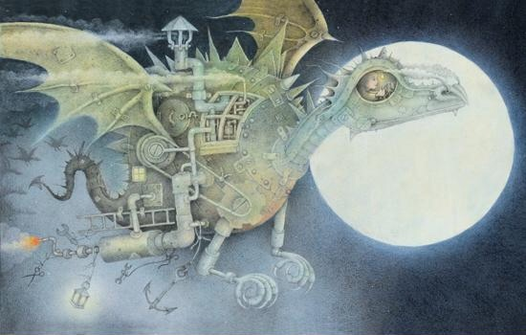

Thursday 25th March
LO: To write sentences to explain
How do you think the dragon machine works? What do the different parts do?

