LO: To write dialogue as direct speech with accurate punctuation

- Add the punctuation to each item of dialogue

Example 1 check

Sam said "You'll never guess what I've just seen"

Louise asked "What's that"

Replied Sam "Our teacher has a broomstick and a black pointy hat in the back of her car. I think she's a witch"

Example 2 check

"You'll never guess what I've just seen" said Sam

"What's that" asked Louise

"Our teacher has a broomstick and a black pointy hat in the back of her car. I think she's a witch" replied Sam

Example 3 check

"You'll never guess what I've just seen" said Sam "Never"

"No guesses mate" Louise replied "Just tell me"

"Okay" he grumbled "Our teacher has a broomstick and a black pointy hat in the back of her car. I think she's a witch"
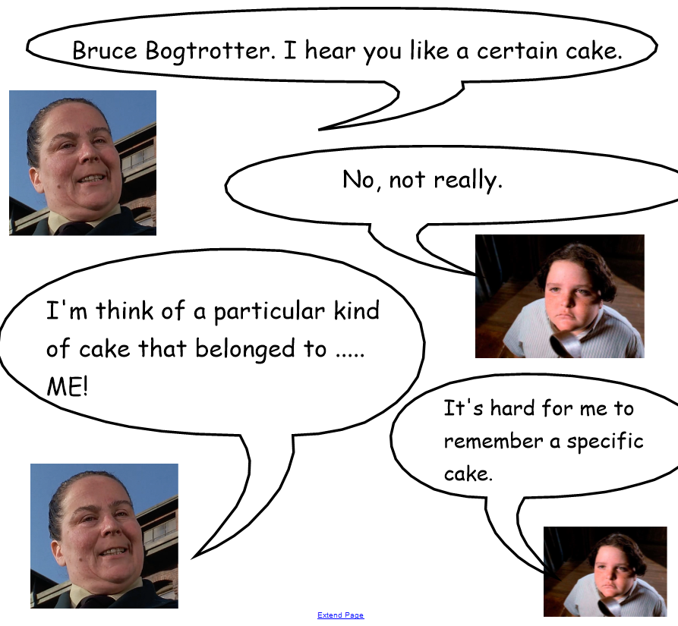

- Write direct speech for the conversation above.

