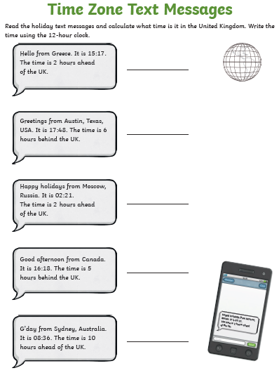

Challenge Activity

Wonky Watches

Mandeep's watch loses two minutes every hour.
Adam's watch gains one minute every hour.
They both set their watches from the radio at 6:00 a.m. then start their journeys to the airport. When they arrive (at the same time) their watches are 10 minutes apart.
At what time (the real time) did they arrive at the airport?

