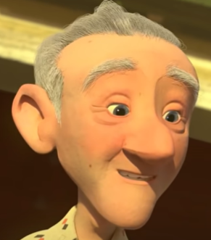
Tuesday 16th March
LO: To generate adjectives to describe characters

We have continued to watch the short film “Taking Flight”. Today, we worked as a class to write a kenning based on the Grandad in the story. Here is our completed kenning poem.

Grandad

