LO: To find out about the Shang Dynasty and explore how we know about it.
History books about the Shang Dynasty were not written until long after the Shang Dynasty had ended. It wasn’t until much later still that archaeologists discovered evidence of the Shang Dynasty. The evidence they found didn’t always support the writings in the history books.
Work with your partner. Read the information sheet then use what you have found out to decide which of these statements is true.
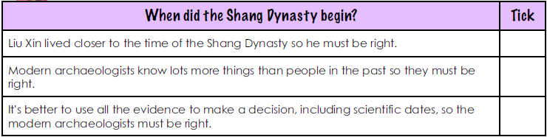
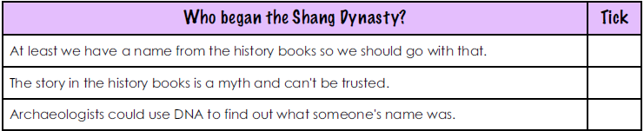
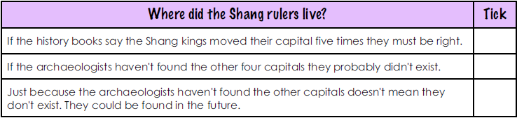
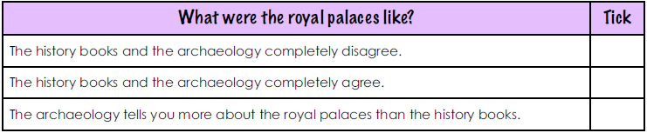
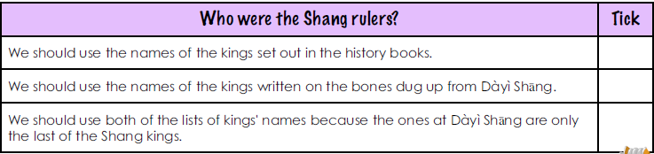
Which is a more reliable source of evidence, archaeology or history books? Write a brief paragraph to explain your answer.

